GAS Early Years Plan Template – High Count High-Rate School(s)
The following Early Years Plan template assists school divisions in implementing high-quality actions to support children to be ready to learn in the primary grades. High Count High Rate (HCHR) schools are the product of cross-referencing count-based and rate-based lists of schools at entry. In addition to having large numbers of students at Tier 2 and 3, these schools are also among the most objectively vulnerable in the sense that children arriving for kindergarten in these schools are amongst the most likely to experience difficulty with developmental tasks.
The Early Years Plan template is divided into three sections: 1. Gather, Analyze and Interpret Data, 2. Create a Plan Based on Data, and 3. Evaluate Effectiveness, Respond and Adjust. When developing your plan, please refer to Responsive Teaching, Practice and Assessment in Early Learning Programs.

School Division: NWSD # 203
Contact(s): Mrs. Griffioen, Mr. Radford
Phone Number: (306) 236-5905 Email: ashley.griffioen@nwsd.ca, michael.radford@nwsd.ca
Gather, Analyze and Interpret Data | Analysis and Summary of Current Situation
EYE  Fall 2022 EYE data summary - comparison of school division data to HCHR school data | Our two HCHR schools account for nearly 50% (44.7%) of students in the division identified with difficulty at school entry in 2022-23; last year Lakeview accounted for approximately 30% of students in the division and Jubilee approx. 8% so a total of 38% of students in the division.  2022- Lakeview- 56.6% (43 students); 2023- 66% (35 students); currently have 4 PreK programs and FTED K  2022- Jubilee- 42.9% (12 students); 2023- 62.3% (33 students); currently have 4 PreK programs and FTED K
Longitudinal Data – How does current EYE data at HCHR school compare to previous years? Is there a longitudinal trend? | 2021/22 School Year EYE-TA Data:  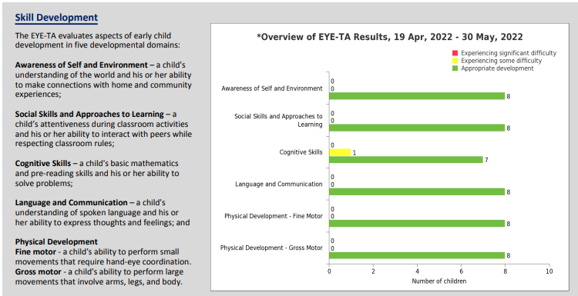  GAS data shows that we had a student who is Tier 2 in Cognitive Skills – a child's basic mathematics and pre-reading skills and his or her ability to solve problems.  2022/23 School Year EYE-TA Data:  Fall Eye-TA Data Results (Total K Students 8)  Tier 1 (Green/Can Achieve Tasks): 75% (6/8)  Tier 2 (Yellow/Experiencing Some Difficulty): 25% (2/8)  Tier 3 (Red/Experiencing Significant Difficulty): 0% (0/8)
Additional Data- any additional relevant data and/or anecdotal information regarding the school | One student is an EAL student  GAS Kindergarten screens- SLP (including hearing screens)  No OT screens were administered this year-change in the service delivery model  Used “look Fors” for planning, assessment, reflection, and PGP’s
Data Sharing – Who has the data been shared with? Relevant feedback? | GAS Early Years team meetings to analyze the data and have conversations about what the data means.  Meet ongoing and frequently throughout the year to analyze data, identify needs, plan interventions, and monitor progress  Data shared with parents  Create Early Years plan for the next school year
Analysis – root causes, relevant factors | One student is an EAL student  One student transitioned from another school part way through the year
Additional Comments: | Analyze data after spring assessments are completed to help develop transition plans for grade 1
Create a Plan  Based on Data | Actions in Response to Data Analysis | Timeline
Division-wide Response – Actions being taken across all programs etc. | Promote PreK and K programs in collaboration with other agencies; ensure the same language is being used; schools to create Welcome packages and promote Early Years;  Look at intake processes and refine them as needed; communicate expectations and guidelines  Explore various PD opportunities and resources ie: language and communication, and social-emotional learning; provide in-person PD to support consistent early learning practices and opportunities to collaborate as early learning educators  Mentors- pair up PreK and K teachers to act as mentors for one another; include site visits  Continue to utilize the CELF-P in all PreK and K rooms to gather age-appropriate data.  Division personnel meet with school team and outline roles and responsibilities; continue to meet monthly, or as needed. Use this time to embed PD and provide interventions  Complete referrals to outside agencies as needed; continue to collaborate with SHA and other agencies to identify and meet students’ needs and provide support.  EYE results, and other assessments, are shared with parents in November.  Family engagement events- strategic and intentional  Home visits- expected to do 3 per family in PreK  Some schools have students attend on Fridays to receive targeted interventions  ELIS spaces have increased from 4 to 14 spots. Continue to promote these spots and support students and schools to meet their needs  Engage with Elder and/or Language Keepers  Breakfast, snack and lunch programs provided as needed  Have new teachers/EAs complete the Ministry PreK/K Basics workshop. Extend invitation to others as well  Continue to use Teams to share ideas and resources, and to ask questions | Spring 2023  Continuously  August 2023  Fall 2023  Fall 2023  As needed  November 2023  Monthly  Throughout the year- Fall, January, and spring  Continuously  Continuously  Daily  Fall 2023  Ongoing
Division Actions specific to the HCHR school – reallocation of staff etc. | Two new principals in both of these schools, thus, provide support and guidance throughout the year and on a regular basis.  Look at adding additional EA time for speech and language needs; also provide additional SLP time  Lakeview provided recommendations in their plan to support them, thus, work with them and other personnel to achieve goals | 2023-24 school year  Fall 2023  Spring 2023
School Response – actions being taken at the school level | GAS EYE/RTI/SSST teams meet regularly to develop, implement, and refine the EY plan based on:  - triangulated data collected from the classroom (As/For/Of Learning)  - collected Eye Data,  - and consultation with SLP/OT/SSST/Admin  Administer learning and cognitive assessments in K if needed (SLP/OT/Ed Psych) | Ongoing
Additional Comments: | Continue to tweak the plan as the year goes on; collaborate with Division Literacy and Math teams and Learning Coaches  Promote EYE Family cards to share with families | Ongoing  Ongoing
Evaluate Effectiveness, Respond and Adjust | Plans to Evaluate Effectiveness | Any Actions to Prepare for Implementation
Research, Data and Analysis- What data is/will be available/gathered to determine effectiveness of actions? (EYE data, teacher/staff feedback etc.) | GAS EY/RTI/SSST teams meet regularly to develop, implement, and refine the EY plan based on:  - triangulated data collected from the classroom (As/For/Of Learning)  - collected Eye Data,  - and consultation with SLP/OT/SSST/Admin  GAS school team will submit an Early Years plan and a follow-up meeting will be scheduled | Schedule time for meeting with EY team members
Transitions – What actions/supports will be needed for successful transition? | GAS teachers will schedule transition meetings for all students (K), have planned interventions in place right away in Sept, continue Individual transition plans for students on IIPs, and Plan K transitions to Gr. 1 starting in May | Schedule time for meeting with EY team members
Respond and Adjust- potential plans for HCHR school for fall 2022 (PD, reallocation of resources etc.) | Promote and advertise K in our communities  GAS K areas of focus- cognitive, language and communication. GAS will utilize EYE 100 activities to strengthen domains https://app.earlyyearsevaluation.com/materials/index?view=eye100&nav=false  GAS will continue to collaborate with SLPs, OTs, psychologists, and counsellors to identify barriers and gaps to respond to needs Supporting Student Assessment in Saskatchewan  GAS will continue to provide responsive instruction to meet the needs of our students NWSD Responsive Instruction Look Fors  NWSD Responsive Instruction Look Fors  GAS will use NWSD Effective Literacy Instruction Effective Literacy Look Fors | Schedule time for meeting with EY team members
Additional Comments:

Superintendent/Early Learning Consultant Signature__________________________________________ Date_______________________

