Your School Name  Level 3 Action Plan 2023-2024 |  |  | 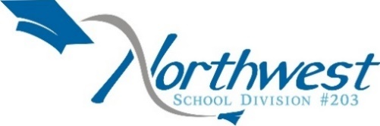
Leads: Deputy Director (Jennifer Williamson); Superintendents of Learning (Cheryl Treptow, Dawn Paylor) | Team Members: Division Staff |  | Date Last Updated: June 8, 2023
Current Situation
2023-2024 is the first year of the new Provincial Education Plan. The plan incorporates new elements for the education sector as well as enduring strategies from previous plans that have successfully improved student outcomes.  The goals for students are:  - I am learning what I need for my future.  - I feel safe and supported.  - I belong.  - I am valued.  - I can be myself.  The four priority actions are framed around the goals. All four actions are of equal importance:  - Improve student outcomes through effective assessment practices that guide and strengthen responsive instruction.  - Enhance opportunities for learners and their families and support transitions as learners enter and progress through school to graduation and determine a life pathway.  - Enrich and enhance mental health and well-being capacity in students.  - Actualize the vision and goals of Inspiring Success: Prek-12 First Nations and Metis Education Policy Framework. |  | 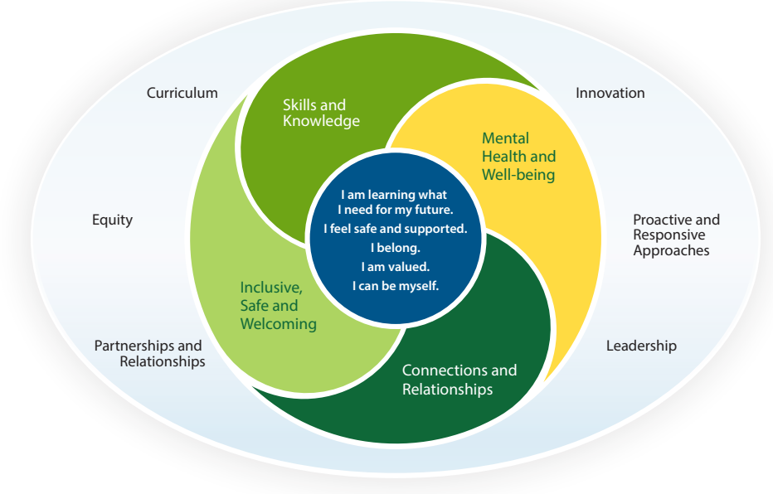

Division Level Action Plan: Supporting Student Learning and Assessment
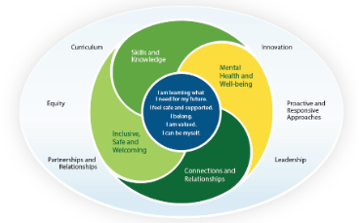 | Priority Action:  Improve student outcomes through effective assessment practices that guide and strengthen responsive instruction. |  | Which PEP Areas of Focus does this action plan support?  - Skills and Knowledge
Enduring Strategies  What are the practices that will continue in support of this priority action? |  |  | Progress Monitoring  What tools will help measure progress?
- Collect and submit grades 1-3 reading data to the Ministry of Education in June 2024  - Offer Balanced Math Pilot  - Offer Literacy Pilot  - Implement Learning Checks with a focus on Responsive Instruction  - Implement individualized reading support plans for students below who are below reading level, which includes: assessment, targeted intervention, and progress monitoring  - Utilize Ministry developed modules for Assessment-Supporting Sask Students  - Provide Mentorship for new teachers  - Utilize Learning Coaches to support and enhance responsive instruction  GAS Enduring Strategies:  - F&P K-8  - IRP/IMP 1-8  - NWSD Math Screens 1-8  - Literacy Look Fors  - Balanced Math Checklist  - Responsive Instruction Look Fors  - Balanced Math K-8 (Utilization of MathUP)  - Literacy Blitz K-8 (Focus on Reading & Writing)  - Student Mentorship Program (K-8) |  |  | - Early Years: EYE-TA and EYE-DA  - Reading: Fountas and Pinnell  - Math: Math Screens  - OurSCHOOL Perceptual Surveys  *New provincial assessments will be implemented as they are developed and released by the Ministry of Education  Other Measures  - Credit Attainment  - Graduation Rates  - Math ORAs  - Literacy Look Fors  - Balanced Math Checklist  - Responsive Instruction Look Fors  - NWSD Supervision Document
Milestones  What milestones are required to complete the outcome? | Steps/ Deliverables  What key actions will you take to achieve the priority outcome? | Timeframe  For starting and Completing the Action | Lead(s)  Who is responsible for the action? | Resources Required Human and Financial
- Implement the Provincial Assessment Plan | - Communicate information and share materials as they become available. | Aug 2023-June 2024 | Ministry of Education  Superintendents of Learning;  School Administrators | Ministry Documents/Work  Appendix A Teaching and Learning.docx
- Identify and support responsive teaching strategies:  - Research effective strategies; and,  - Develop/recommend resources and professional learning. | - Update and utilize the NWSD teacher supervision document to reflect current practices in assessment and responsive instruction. | Aug 2023-June 2024 | Superintendents of Learning;  School Administrators | Supporting Student Assessment in Saskatchewan
 | - Update current NWSD assessment document to align with “Supporting Student assessment in Saskatchewan” | Aug 2023-Dec 2023 | Superintendents of Learning;  Learning and Assessment Consultant | AP360  Supporting Student Assessment in Saskatchewan
 | - Pilot Balanced Math for final year-aligned with responsive teaching and assessment strategies (Full implementation to begin 2024)  GAS Balanced Math Participation:  - 1-2 Already Participating  - 3-4 Participating Next Year  - 5-8 Already Participating | Aug 2023-June 2024 | Superintendents of Learning;  Learning Coaches;  Pilot Teachers | NWSD Math Hub  Balanced Math Look Fors
 | - Pilot Literacy Project-aligned with responsive teaching and assessment strategies | Aug 2023-June 2024 | Superintendents of Learning;  Learning Coaches;  Literacy Team;  Pilot Teachers | NWSD Literacy Hub  Effective Literacy Look Fors
 | - Explore Professional Learning Communities with a Working Group | Aug 2023-June 2024 | Superintendents of Learning
 | - Implement instructional leadership practices that strengthen responsive instruction and assessment. (ie. Establishing goals and expectations, resourcing strategically, ensuring quality teaching, leading teacher learning and development, ensuring an orderly and safe environment)  - Aligning staff PGPs to SAP (Responsive Instruction Goal, Inspiring Success Goal, & Mental Health Well Being Goal)  - Leading School PD at Staff Meetings (Ref to PD Plan)  - Monthly Walkthroughs in every classroom  - Collaboratively setting goals  - Purchasing resources  - Staffing Decisions based on what’s best for students | June 2023-June 2024 | School Administrators | NWSD Responsive Instruction Look Fors  Continued Instructional Leadership PD
 | - Develop and implement instructional goals based on teaching strategies listed in the document NWSD Responsive Instruction Look Fors and “Supporting Student Assessment in Saskatchewan” Modules  - GAS staff will use division, provincial, classroom data (as/of/for learning), and NWSD Responsive Instruction Look Fors to determine the next steps for classroom-based intervention (Tier 1/2/3).  - GAS staff will improve Classroom-based Instruction (Tier 1) through Responsive Instruction Modules; multilevel instruction, critical elements of reading instruction, and effective instructional practices in Math (Balance Math)  - GAS staff we will focus on improving assessment for learning by utilizing formative assessments and providing ongoing feedback | June 2023-June 2024 | School Administrators;  Teachers | NWSD Responsive Instruction Look Fors  Supporting Student Assessment in Saskatchewan  Responsive Instruction Modules  https://www.adlit.org/in-the-classroom/strategies
 | - Pilot schools will implement open gradebook to support timely reporting and communication with stakeholders (Edsby). | Aug 2023-Ongoing | Pilot School Administrators and Teachers | EDSBY Professional Learning

Division Level Action Plan: Inspiring Success
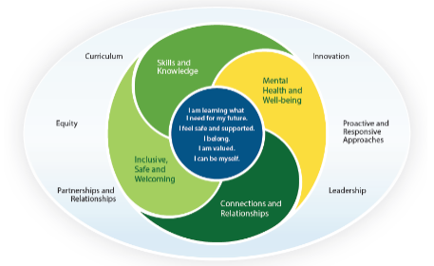 | Priority Action:  Actualize the vision and goals of Inspiring Success: Prek-12 First Nations and Métis Education Policy Framework |  | Which PEP Areas of Focus does this action plan support?  - Skills and Knowledge  - Mental Health and Well-Being  - Connections and Relationships  - Inclusive, Safe and Welcoming
Enduring Strategies  What are the practices that will continue in support of this priority action? |  |  | Progress Monitoring  What tools will help measure progress?
- Continue to build background knowledge and application of Inspiring Success  - Continue to provide 4 Seasons of Reconciliation professional learning modules  - Continue to utilize the expertise of the Indigenous Learning Coach  - Continue to identify and provide professional learning for Lead Learners in each school  - Continue to utilize Truth and Reconciliation kits  - Cultural Camp  - FTV in 7 schools  - Offer the Northern Lifestyles course (virtual)  - Indigenous Education Responsibility Framework  - Continue to offer Indigenous Languages-Michif Kindergarten  - Providing support to teachers and administrators in continued work with Elders and Knowledge Keepers  GAS Enduring Strategies:  - FNMI Lead Learner  - FNMI Learning Coach  - FNMI Teams Resource Page  - Four Seasons for Reconciliation PD  - FNMI Resources on NWSD Website  - Land acknowledgements  - Elder Visits  - Understanding of protocol for Elders  - Sharing in FNMI Celebrations and Important dates  - Indigenous Language visible in school |  |  | - OurSCHOOL Perceptual Surveys  - Indigenous Education Responsibility Framework  - Culturally Responsive Teacher Survey (adapted from p. 126 of Supporting Student Assessment in Saskatchewan)  Other Measures  - 3-year graduation rates, disaggregated for Indigenous, non-Indigenous and all students;  - 5-year graduation rates disaggregated for Indigenous, non-Indigenous and all students
Milestones  What milestones are required to complete the outcome? | Steps/ Deliverables  Key actions taken to achieve the priority outcome | Timeframe  For starting and Completing the Action | Lead(s)  Who is responsible for the action? | Resources Required Human and Financial
- Assess and ensure that the policy goals of Inspiring Success are being implemented: | - Analyze the 2022-2023 IERF data to inform decision making and planning. | August 2023 – June 2024 | Superintendents of Learning; Indigenous Learning Coach; School Administrators; Teachers | Indigenous Education Responsibility Framework (IERF)
Policy goals of Inspiring Success:  - First Nations and Métis languages and cultures are valued and supported.  - Equitable opportunities and outcomes for First Nations and Métis learners.  - Shared management of the provincial education system by ensuring respectful relationships and equitable partnerships with First Nations and Métis peoples’ authentic assessment measures that foster improved educational opportunities and outcomes.  - Culturally appropriate and authentic assessment measures that foster improved educational opportunities and outcomes.  - All learners demonstrate knowledge and understanding of the worldviews and historical impact of First Nations and the Métis Nation. | - Continue to use the Indigenous Education Responsibility Framework (IERF) to determine measures to track progress on the goals of Inspiring Success and assess local actions. | August 2023 - Ongoing | Superintendents of Learning; Indigenous Learning Coach; School Administrators | Indigenous Education Responsibility Framework (IERF)
 | - Provide continuous professional development for teachers and administrators in response to identified areas of improvement based on the IERF: Cultural Camp, FNMI Lead Learners. | August 2023-June 2023 | Superintendents of Learning; Indigenous Learning Coach; School Administrators
 | - Schools involved with Following Their Voices initiatives will implement Lilac plans. | Ongoing | FTV School Administrators; FTV Leads; Teachers | FTV Resources  Elders/Knowledge Keepers
 | - Schools will utilize expertise of Indigenous Learning Coach to promote and enhance goals of Inspiring Success. | Ongoing | Indigenous Learning Coach; School Administrators
 | - Continue to infuse Treaty Outcomes and Indigenous ways of knowing in learning. | Ongoing | School Administrators; Teachers | Elders/Knowledge Keepers  Indigenous Learning Coach  Reconciliation kits
 | - Utilize Indigenous Cultural Teacher in partnership with Flying Dust as per ISSI Grant (Meadow Lake Schools). | August 2023- June 2024 | Superintendents of Learning; Indigenous Learning Coach | Invitational Shared Services Initiative (ISSI) Grant
 | - Expand Michif Language Early Learning program | August 2023- June 2024 | Lakeview School | Michif Grant from Métis Nation
 | - Develop and implement instructional goals including culturally affirming assessment practices and culturally responsive pedagogies from Module 3: Using Culturally Inclusive and Affirming Assessment Practices (pp. 95-133; specific examples can be found on pages 110-112))  GAS Instructional Goals:  Intentional and developmental exposure, experience, and engagement in  learning for all staff and students:  - Follow Indigenous Day of Significance at school  - Provide FNMI learning opportunities in the classroom (Blanket Exercise/Treaty Simulation/Indigenous worldview/ways of knowing/ 7 Sacred Teachings/Repeat After Me language teachings on Facebook)  - Elder and Knowledge Keeper visits  - Provide 3 Land-Based Learning Activities throughout the year (Fall/Winter/Spring)  Investigate, acknowledge, and respond to truth, history, and land, challenge bias and stereotypes  - Continue Leading to Learn PD  - Staff PD  - All staff complete 4 Seasons of Reconciliation  Relationships with Indigenous peoples in the local territory  - Ensuring that protocol is followed with Elders and Knowledge Keepers  - Partnership educational experiences with First Nations and Metis organizations (Indigenous Peoples Day, Metis Week)  - Elder and Knowledge Keeper visits  - Sporting events with local First Nation and/or Metis Nation  - Local speakers invited to the school  Data/information management  - Sharing the celebrations  - School Facebook, See Edsby as a communication tool  - Parents are informed with outcomes (SSC SAP Meeting)  - FNMI Section in school newsletters  - Add Inspiring Success/FNMI Goal to staff PGPs  Assessment Strategies  - Observations, conversations, products  - Sharing Circles, Observation checklists  - Student teacher conferencing, KWL talks  - Exit slips, reflective journal entries, portfolios | August 2023-June 2024 | School Administrators; Teachers | Module 3: Using Culturally Inclusive and Affirming Assessment Practices (pp. 95-133)  NWSD Land-based Learning/Cultural Events funding grant

Division Level Action Plan: Mental Health and Well-Being
 | Priority Action:  Enrich and enhance mental health and well-  being capacity in students. |  | Which PEP Areas of Focus does this action plan support?  - Mental Health and Well-Being  - Connections and Relationships  - Inclusive, Safe and Welcoming
Enduring Strategies  What are the practices that will continue in support of this priority action? |  |  | Progress Monitoring  What tools will help measure progress?
- Counselling Supports  - Mental Health First Aid  - Mental Health Plans  - SafeTALK  - ASIST  - VTRA  - Live Well  GAS Enduring Strategies:  - Teach MHL Literacy course (ages 12-15 UBC MHL/CMHA School Kit/Myths & Realities Video)  - Classroom Morning Wellness check-in (Teacher Facilitated)  - Safe, Caring, and Welcoming Schools (SCWS) (Walk Around Tool Kit 3 times per school year)  - Culturally responsive teaching (Adaptive Dimension/Gender and Sexual Diversity)  - Share and celebrate successes throughout the year at WC check-ins and at the end of the year with admin via mini- NWSD symposium  - Student/adult Mentorship program (GAS divide staff up to check in with their group of students)  - Classroom teachers promote a sense of belonging and caring at school through Mentorship program/SLC/Circle of Courage/Morning check-in meetings/Counselor meeting)  - SHA/STF-Mental Health Services Counselor/Student/Parent/Teacher Resources (Shared through Monthly Newsletter “Grizzly Growl”)  - GAS/SCC Community Potlucks (Every other month)-Developing Community connection and Sense of belonging  - SCC Hot lunches (4 per year)-Volunteers from SCC work with GAS grades to prep, cook, and serve hot lunches for GAS staff & students  - GAS Professional development and support staff in developing staff Mental Health:  - Go to Educators: Mental Health Literacy  - Mental Health First Aid for Adults that Interact with Youth  - Trauma-Informed Classrooms  - Pan-Canadian Joint Consortium for School Health Positive Mental Health Toolkit  - STF Professional Learning  - UBCxOnline: Learn Mental Health Literacy  - UBCxOnline: Teach Mental Health Literacy  - STARR Commonwealthhttps://starr.org/courses/ Courses |  |  | - OurSCHOOL Perceptual Surveys  - EYE Early years Evaluations  *New provincial assessments will be implemented as they are developed and released by the Ministry of Education  Others?  - NWSD MHWB Site  - Living Works  - UBC Courses  - CMHA Kit  - SCWS Kit  - TeenMentalHealth.org  - Medicine Wheel  - Star Commonwealth  - Kevin Cameron  - Elders  - Red Cross  - SHA Mental Health  - STF Mental Health  - NWSD Counselors  - SK Ministry Gender & Diversity Documents  - OurSCHOOL survey results  - Kids Help Phone Data  - PSST World- Anonymous online reporting tool  - Trends from counsellors  - TeenMentalHealth.org  - First Nations Mental Wellness Continuum Framework  - Living Works  - UBC Courses  - Columbia Suicide Severity Rating Scale  - Foundations for a Healthy School  - School Mental Health Ontario  - Be There
Milestones  What milestones are required to complete the outcome? | Steps/ Deliverables  Key actions taken to achieve the priority outcome | Timeframe  For starting and Completing the Action | Lead(s)  Who is responsible for the action? | Resources Required Human and Financial
- Create shared understanding for students, families, parents, teachers, administrators, and others by:  - developing common definitions of key terms and concepts; and,  - providing professional development to teachers and administrators. | 1.1 Develop common mental health terminology and identify key concepts and processes. This includes:  - connecting with partners  - identifying stakeholders  - continuing with NWSD mental health and well-being team to attend provincial PD opportunities and provide guidance on the implementation of mental health supports in schools  - Utilizing social media  GAS MHWB Team Members:  - Erin Friesen  - Carrie Klassen  - Michael Radford  MHWB Team Role:  - mental health promotion  - early identification  - prevention, and  - early intervention services  - standard processes and protocols  - partnerships with community agencies  Share common understandings (With whom?)  - GAS school plans will be posted to school websites and shared with SCC in the Fall.  - Shared through Monthly Newsletter “Grizzly Growl”  - Share and celebrate successes throughout the year at WC check-ins and at the end of the year with admin via mini- NWSD symposium  - Shared with staff at staff meeting  Connecting with Community through SCC:  - Share GAS MHWB SAP plan at 1st SCC meeting to document enduring strategies for community connection & sense of belonging  - Seek feedback at 1st SCC meeting about new ideas for connecting with the community:  -Pancake breakfast Potluck  -Donuts for Dads (Fathers Day)  -Muffins for Mom (Mothers Day)  -Monthly recreation & movie nights for community | Sept. 2023-Jan 2024 | Ministry of Education  Deputy Director  School Administrators
 | - Share and review the summary of common social and emotional learning resources and exemplars provided by the Ministry.  Process: GAS wellness team will foster Social Emotional Wellbeing through the following actions:  - Develop, collect data, evaluate, reflect, and revise GAS MHWB PEP/SAP  - Administration and data collection of Safe and Caring Schools (SCS) walk-through (3x/year)  - Develop SMART goals from SCS data analysis  - Collaboration with GAS staff, students, and community  - Monthly meeting to collect data, evaluate, reflect, and revise the Healthy School Environment SMART goal  - Scheduled Wellness class once per every 6-day cycle (Day 6) to administer “Little Spots of Feeling” in k-8 classrooms | Sept. 2023-June 2024 | Ministry of Education  Deputy Director  Student Services  School Administrators | Safe, Caring, & Welcoming Schools  https://www.alberta.ca/safe-and-caring-schools.aspx
 | - Create a shared space for resources, professional development opportunities and collaboration regarding mental health and well-being.  - Share exemplars developed by the Ministry for professional development and classroom actualization of curricular outcomes regarding mental health and well-being.  - Continue to add and edit Community Resources document and to share with schools  - Continue to utilize Not Myself Today for staff  GAS will provide a space for resources on our Teams page, webpage, Facebook, NWSD website | ASAP-Sept. 2023 | Deputy Director  Student Services  School Administrators
 | - Share effective, promising practices and research:  - Monthly meetings  - Monthly newsletters  - Mental health and well-being symposium.  - Ministry of Education resources  - Bi-Weekly bulletins  - Monday e-newsletters  Share common understandings (With whom?)  - GAS school plans will be posted to school websites and shared with SCC in the Fall.  - Shared through Monthly Newsletter “Grizzly Growl”  - Share and celebrate successes throughout the year at WC check-ins and at the end of the year with admin via mini- NWSD symposium.  - Shared with staff at staff meeting | Sept. 2023-June 2024 | Deputy Director  Student Services  School Administrators
- Explore an inter-agency mechanism, locally and provincially to support access to mental health supports for our school system. | 2.1 Share our mental health and well-being priority action plan:  - Key local partners  - NWSD website  - Blackboard  - GAS school plans will be posted to school websites and shared with SCC in the Fall.  - Shared through Monthly Newsletter “Grizzly Growl”  - Share and celebrate successes throughout the year at WC check-ins and at the end of the year with admin via mini- NWSD symposium.  - Shared with staff at staff meeting | June Early July 2023 | Deputy Director  Student Services  School Administrators
 | 2.2 Continue to train staff members in VTRA through collaboration with the Centre for Trauma Informed Practices (CTIP).  GAS will take inventory of staff VTRA training and provide PD opportunities for staff to become VTRA trained. | Sept. 2023-Ongoing | Deputy Director  Student Services  School Administrators  Teachers
 | 2.3 Partner with other agencies to offer MHFA training.  GAS will take inventory of staff MHFA training and provide PD opportunities for staff to become VTRA trained. | Sept, 2023- Ongoing | Deputy Director  Student Services  School Administrators  Teachers
 | 2.4 Apply for the Mental Health grant to support targeted actions for our school division. | Sept 2023 | Deputy Director  Student Services  School Administrators
- Identify and extend high-quality and culturally responsive programs and practices. | 3.1 Explore relevant, equitable and recent trauma-informed mental health and well-being practices.  GAS will take inventory of staff trauma-informed training and provide PD opportunities for staff to move forward. | Sept. 2023-June 2024 | School Administrators  Teachers
- Utilize the self-reflection tool for school systems that can help to assess plans and progress. | 4.1 Utilize the wholistic assessment tool designed by the provincial mental health and well-being subcommittee to review our mental health and well-being plan and identify where there is room for improvement.  - Administration and data collection of Safe and Caring Schools (SCS) walk-through (3x/year). | Sept. 2024-Midway through year 2 |  | Safe, Caring, & Welcoming Schools  https://www.alberta.ca/safe-and-caring-schools.aspx

Division Level Action Plan: Student Transitions
 | Priority Action:  Enhance opportunities for learners and their families and support transitions as learners enter and progress through school to graduation and determine a life pathway. |  | Which PEP Areas of Focus does this action plan support?  - Skills and Knowledge  - Connections and Relationships  - Inclusive, Safe and Welcoming
Enduring Strategies  What are the practices that will continue in support of this priority action? |  |  | Progress Monitoring  What tools will help measure progress?
- Family Engagement with SCC involvement  - My Blueprint  - Partnerships with outside agencies – including Flying Dust, ECIP, Family Resource Centre, KidsFirst, Hub and VTRA partners.  - Copes, Caps, Cops  GAS Enduring Strategies:  - All About Me (5-6)  - OurSCHOOL Survey  - Safe and Caring Schools (SCS) walk-through (3x/year) |  |  | - Early Years: EYE-TA and EYE-DA  - Reading: Fountas and Pinnell  - OurSCHOOL Perceptual Surveys  Other Measures  - Credit Attainment  - Graduation Rates  Others?  Safe, Caring, & Welcoming Schools  https://www.alberta.ca/safe-and-caring-schools.aspx
Milestones  What milestones are required to complete the outcome? | Steps/ Deliverables  Key actions taken to achieve the priority outcome | Timeframe  For starting and Completing the Action | Lead(s)  Who is responsible for the action? | Resources Required Human and Financial
- Establish a provincial understanding of family engagement approaches in Prekindergarten to Grade 12 Education:  - Develop a common understanding of terminology.  - Provide professional development to teachers and administrators.  - Determine benchmarks; and,  - Develop additional tools for measurement. | - Communicate information and share materials as they become available from the Ministry of Education.  - Compile research-based engagement approaches and practices and share with schools. | August 2023-Ongoing | Superintendents of Learning  Administrators | Ministry
- Partner with families and providers of early learning, childcare and intervention programing (e.g., Headstart, ECIP, Prekindergarten) to identify and provide supports to young children and their families as they enter schools. | - Continue to develop and utilize current and future partnerships to support students and families with the transition to school.  New young K students will participate in K Meet the Teacher Day at GAS prior to beginning the next school year. | August 2023-Ongoing | Superintendents of Learning  Administrators
- Identify and support student engagement at key transition points as students progress through school. | - Continue to use OurSCHOOL perceptual survey results (grade 4-12), Student Voice data, and FTV tools to support and respond to adolescent engagement by understanding areas of strength and challenges associated with student attitudes towards school and learning.  - Implement consistent communication tool across the school division (EDSBY).  - Schools will implement transition plans for students at key transition points.  GAS key transition points for our students:  - Entering K  - Transitioning from K- Gr. 1/2  - Transitioning from Gr. 1/2 to 3/4  - Transitioning from Gr. 3/4 to 5/6  - Transitioning from Gr. 5/6 to 7/8  - Transitioning from Gr. 8 (GAS) to 9 (CHS) | August 2023-Ongoing | Deputy Director  Administrators  Teachers | Family Advocate  Wellness Coordinators  EdPsych  Counsellors
- Identify and extend opportunities that assist students to prepare for diverse career and life pathways through partnerships with post-secondary education and training, business, and industry. | - Full utilization of myBlueprint (Grades 7-12).  - Create partnerships between K-12 postsecondary and industry stakeholders to identify and advertise various lifepaths for students.  - Promote and optimize dual credit options, apprenticeship, and other educational opportunities that might arise. | August 2023-June 2024 | Administrators; Teachers; Learning Coach (Career Counselling)

