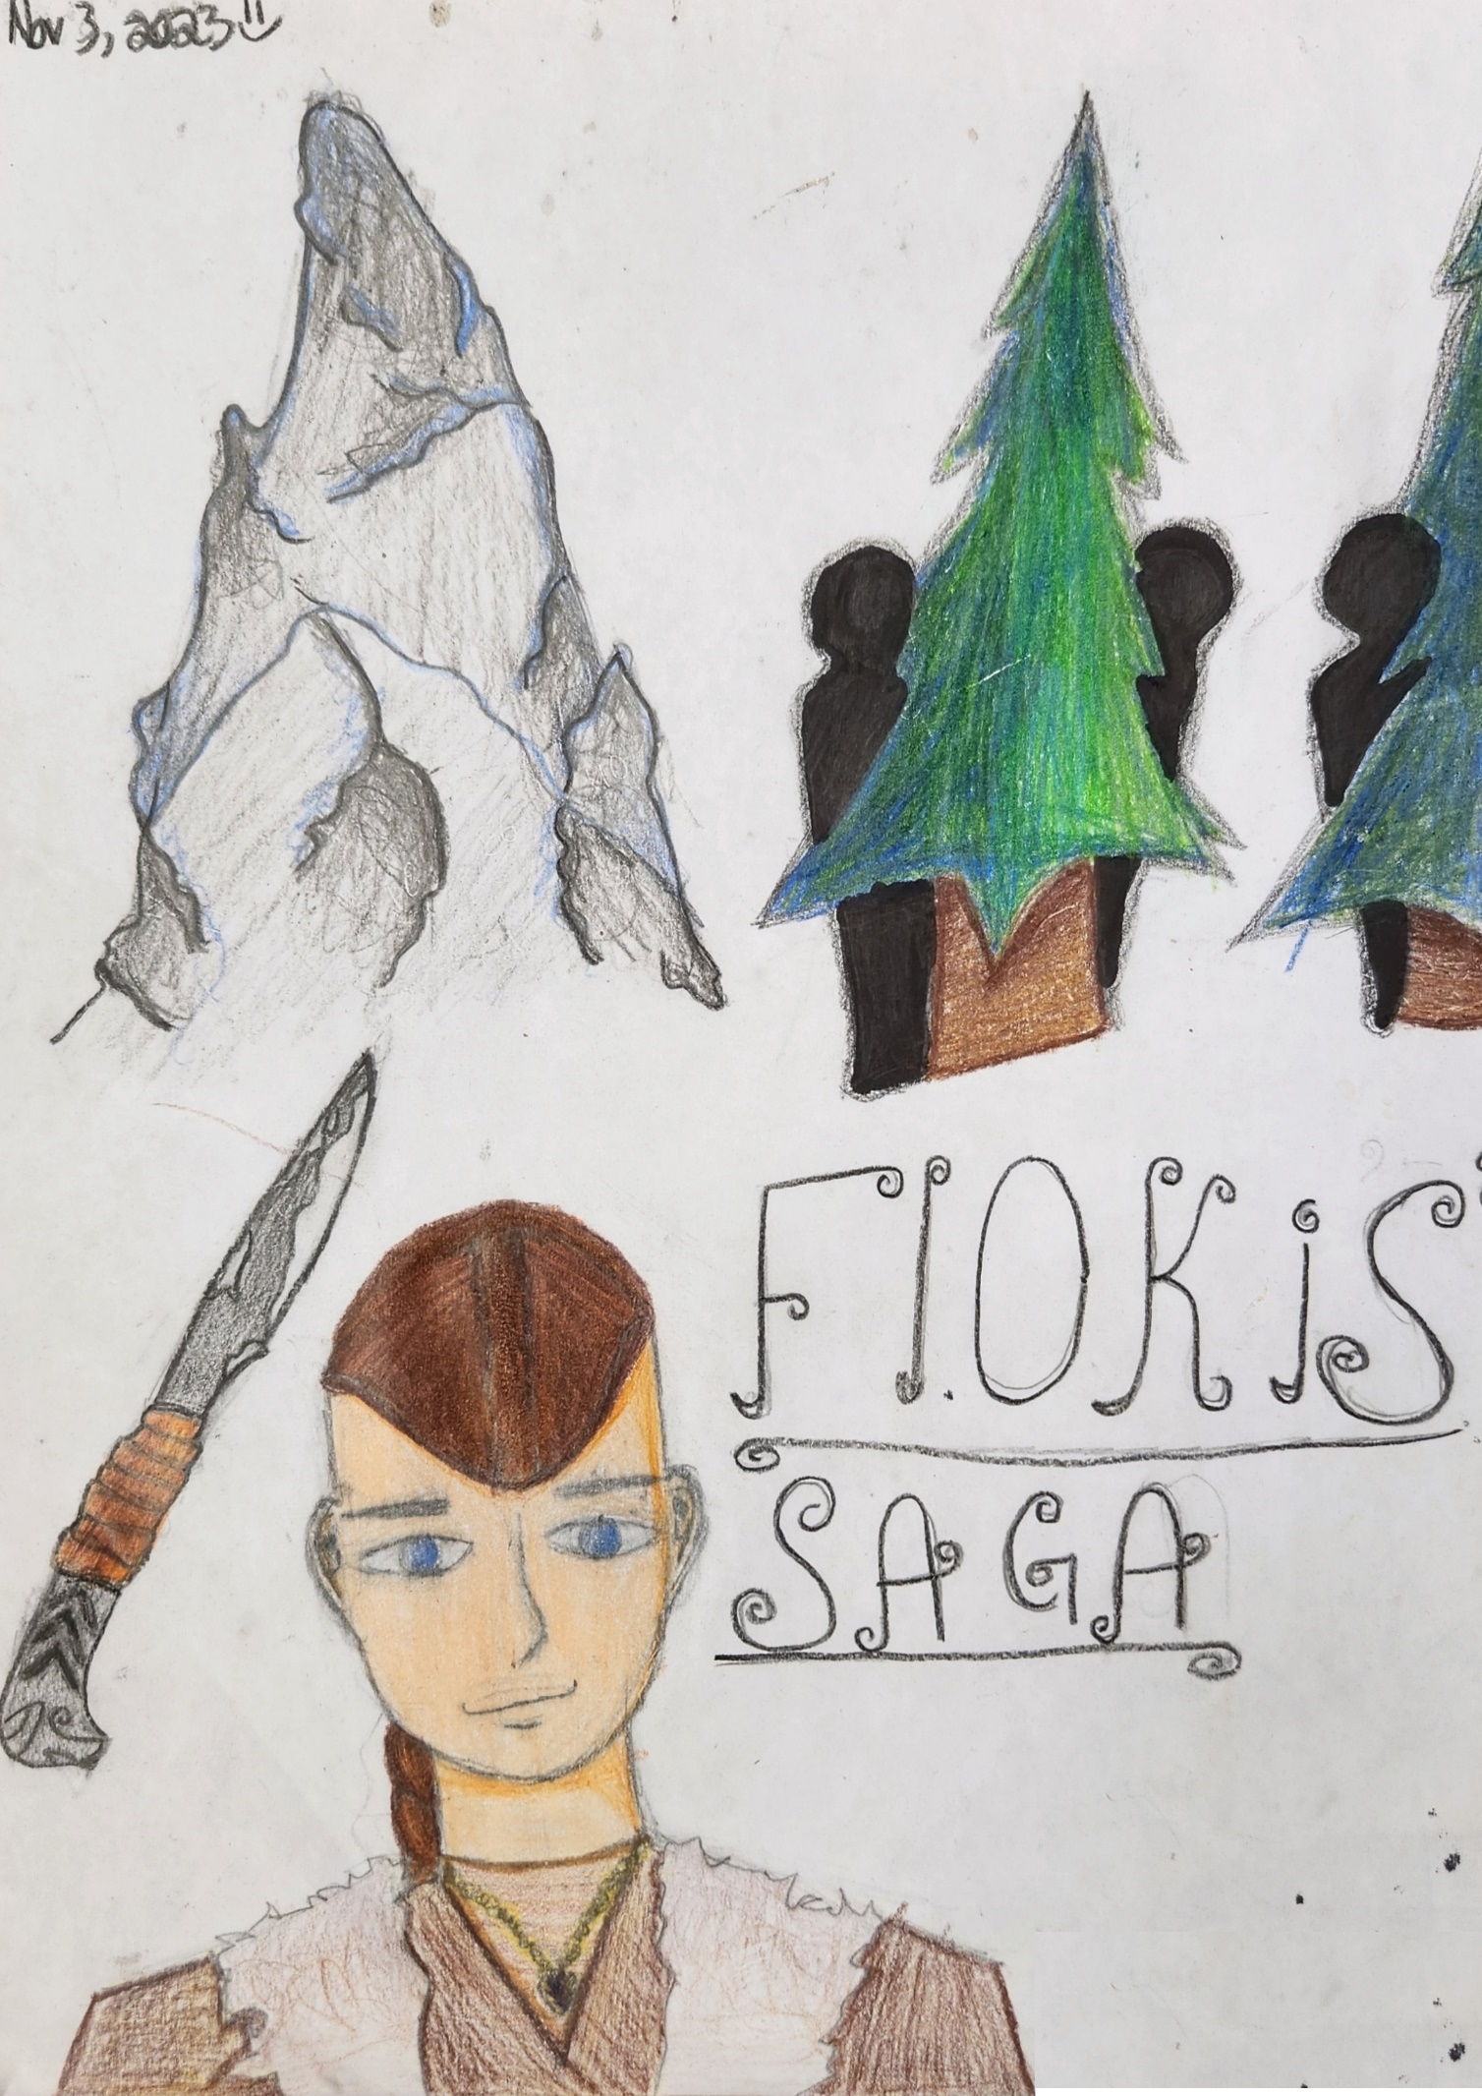
THE YEAR WAS 935. A YOUNG BOY IN HIS MID-TEENS WITH A LONG GINGER BROWN BRAID AND BEAUTIFUL, BRIGHT GREY-BLUE EYES WAS WALKING HOME. HIS NAME WAS FLOKI, AND IT WAS A DARK AND STORMY NIGHT, IN THE VIKING VILAGE OF SHMARKENBORRG. HE WAS COMING HOME FROM HUNTING WILD GAME IN THE FORESTS. WHEN HE GOT TO HIS VILLAGE IT WAS PITCH BLACK AND HE HAD TO USE HIS TORCH TO SEE HIS WAY.
WHEN HE REACHED HIS CABIN OUTSIDE THE VILLAGE ON THE NORTH SIDE OF SHMARKENBORRG, HE WENT IN THE HOUSE, TOOK OFF HIS BOOTS AND WENT TO GET READY TO SLEEP. BUT WHEN HE WENT TO GET IN HIS NIGHT CLOTHES AND GET CHANGED, HE SAW IT. HIS MOTHER, ON THE GROUND BLOOD ON THE FLOORS AND A DAGGER IN HER CHEST. THE BLOOD HAD STAINED HER CLOTHES AND HER LOCKET WAS COVERED IN IT. FLOKI RUSHED OVER CHECKING TO SEE IF SHE WAS STILL ALIVE. SHE WAS. THERE WAS STILL A HEARTBEAT BUT FAINT. HER LIGHT GREEN EYES WERE DULL WITH NO SHINE.
FLOKI RUSHED OUT THE HOUSE AND STARTED YELLING FOR HELP HIS BLOODY HANDS WAVING IN THE AIR. THE CHIEF SAW THIS AND GOT THE HEALERS TO COME AND SAVE HER, BUT IT WAS TOO LATE. FLOKI’S MOTHER WAS DEAD AND HE WAS ALL ALONE NOW.
THE CHIEF GESTURED TO HIM TO COME OUTSIDE, HE WANTED TO TALK TO FLOKI. “I KNOW WHAT YOU DID,” CHEIF SAID IN A DEEP MELLOW VOICE.
“WHAT DO YOU MEAN CHEIF EINER?” FLOKI REPLIED.
“YOU KILLED ‘ER.”
“ME MOTHER? YOU THINK I KILLED MY OWN MOTHER?!” FLOKI SAID IN A SHOCKED AND ANGRY VOICE.
“THERE WILL BE A TRIAL. YOU IN THE VILLAGE SQUARE ON THE 2ND MOON AT MI’NIGHT SHARP.”
THAT WAS TOMORROW NIGHT. FLOKI TRIED TO SPEAK BUT CHIEF EINER WAS ALREADY HALFWAY DOWN THE PATH TO THE CHIEF’S QUARTERS.

THAT NIGHT FLOKI COULDN’T SLEEP AT ALL. HE JUST LOOKED AT THE STARS AND CRIED…
ON THE 2ND DAY FLOKI GOT READY FOR THE TRIAL. HE GOT INTO HIS CLOTHES. AS THEY WERE RAGGEDY FLOKI HAD TO SEW THE HOLES IN HIS SHIRT, HIS PANTS, SOCKS, AND HIS COAT OF SHEEP WOOL. NEXT, HE GOT CHANGED, PACKED HIS SATCHEL WITH GOODS FOR TRADING AND SET OFF.
THE FIRST THING HE HAD TO DO WAS FEED THE SHEEP AND THE PIGS, NEXT HE WENT TO THE VILLAGE BUT EVERY TIME HE WALKED PAST SMEONE, THEY WOULD LOOK AWAY OR GASP AND GET SCARED IF THEY HAD CHILDREN, THEY WOULD MAKE THEM LOOK AWAY.
HE KNEW IT WAS BECAUSE THE CHIEF SPEWED THE RUMORS, “YOU KILLED ER’!”
“SHE’S DEAD BECAUSE A’ YOU!”
“WHY FLOKI WHY?!”
“IM VOTING TO KICK YOU OUT, I’ COULD B’ ME NEXT!”
THE WORDS FROM THE PEOPLE FLEW THROUGH HIS HEAD LIKE ASH FLOWING THROUGH THE WIND… “WHY ME?” FLOKI THOUGHT.
HE EVEN WENT TO HIS BEST FRIEND “GEH’ AWAY!!” HIS BESTFRIEND YELLED.
“EVEN YE’!?” FLOKI MURMERED AS HE RAN AWAY. TEARS RAN DOWN HIS FACE LIKE A HEAVY RAIN ON A SPRING DAY.

THE TRIAL
IT WAS NOW 5 MINUTES UNTIL THE TRIAL AND FLOKI WAS ON HIS WAY TO THE MAIN SQUARE, “I’M BOUT’ TO BE LATE!” FLOKI ANGRILY WHISPERED TO HIMSELF AS HE PACED INTO A RUN.
HE WAS FINALLY THERE. “YOURE LA’E,” CHIEF EINER SAID IN A MELLOW VOICE,
FLOKI REPLIED, “IM SORRY.”
“ANOTHER REASON YOU SHOULD LEAVE OI’.” CHIEF SAID. “SO, WHO E’R VOTES FLOKI TA LEAVE?” ABOUT 34 PEOPLE RAISED THEIR HAND, “AND WHO E’R VOTES IM’ TA’ STAY?” NOW, ABOUT 9 PEOPLE RAISED THEIR HAND.
“LOOKS LIKE SOMEONE IS LEAVIN’ TOMORROW!” HIS BEST FRIEND SAID FROM THE CROWD.
“AIT’, IT BE SOLVED, FLOKI BE LEAVIN’ TOMMORROW,” SAID THE CHIEF. FLOKI THEN LEFT AND RAN TO HIS HOUSE, VOICES IN HIS HEAD WHISPERING AS THE TOWN WHISKED BY….

LEAVING HOME
IT WAS NOW EARLY MORNING FLOKI HAD JUST WOKEN UP. HE STARTED TO PACK, FIRST HE GRABBED HIS WARMEST CLOTHES AS ITS TURNING TO LATE FALL AND THERE ARE ONLY A FEW DAYS TILL’ WINTER. NOW HE PACKED SOME DRY MEAT (JERKY) AND A LEATHER BOTTLE OF WATER WITH A PINE CAP FOR EXTRA PROTECTION AND LASTLY HIS MOTHERS LOCKET, IT WAS A SMALL GOLDEN HEART WITH A SILVER CHAIN AND A LUPIN FLOWER ON THE TOP. “IT WAS HER FAVOURITE FLOWER,” HE THOUGHT.

THE FINAL PRAYER
THE LAST THING HE DID WAS PRAY TO THE GODS, PRAY TO THE GODS HE CAN MAKE IT TO THE NEARBY MOUNTAIN VILLAGE OF HOMBJARG.
HE STARTED TO ASCEND TO THE MOUNTAINS STEP BY STEP BY STEP. HE THEN SAW SOMETHING HE’D NEVER SEEN BEFORE…. THE SAME DAGGER THAT KILLED HIS MOTHER IN A MERCHANT’S HAND. “HEY YOU!” HE YELLED TRYING TO CATCH UP. BUT IT WAS TOO LATE THE MERCHANT HAD VANISHED…
HE THOUGHT IT WAS ALL IN HIS HEAD AND CONTINUED ON HIS JOURNEY TO THE MOUNTAIN VILLAGE. IT WOULD BE A LONG WAY BEFORE HE GOT THERE AND IT WOULD BE DARK SOON. SO, HE DECIDED TO MAKE CAMP ON THE NORTH ROAD.

CAMP DANGER
HE STARTED TO SET UP CAMP, A SMALL TIPI STRUCTURE. “THIS’LL DO,” HE THOUGHT AS HE COVERED IT IN HUGE SPRUCE BRANCHES FOR INSULATION. IT WASNT LONG BEFORE HE FINISHED AND IT WAS ALREADY GETTING DARK SO HE MADE A FIRE, SAID A PRAYER AND WENT TO SLEEP.
IN THE MIDDLE OF THE NIGHT, HE WOKE UP TO THE SOUNDS OF FOOTSTEPS OUTSIDE OF HIS TENT. HE SLOWLY LOOKED OUTSIDE OF THE TENT FROM THE CRACK, IT WAS TOO DARK EVEN SEE WITH THE FIRE GOING. HE CAN’T LOOK CLEARLY, SO, HE GRABBED HIS AXE AND PREPARED TO FIGHT. HE STEPPED OUT OF THE TENT. BUT NO ONE WAS THERE. “I SWEAR I HEARD SOMETHING,” FLOKI THOUGHT TO HIMSELF.

THE AMBUSH
BUT ALL AT ONCE THREE FIGURES POPED UP FROM THE PITCH-BLACK FOG. THEY STRUCK ALL AT ONCE. IT WAS ALMOST IMPOSSIBLE TO DODGE THEIR ATTACKS, BUT, ONE BY ONE HE SLAMMED HIS AXE INTO THEIR HEADS AS HE HEARD THE BLOOD CURDLING SCREAMS FILL THE AIR. BUT ALL AT ONCE IT WENT QUIET. FLOKI KILLED THEM ALL BUT HIS LEG HAS A HUGE OPEN GASH FROM THE THIGH DOWN TO HIS ANKLE.
“THAT HURTS”
HE WHISPERED LIKE A SMALL CHILD, AS HE WISHED HIS MOTHER WAS THERE FOR HIM. AND HE PASSED OUT….

AWOKEN
HE THEN WOKE UP. IT HAD BEEN’ AT LEAST 6 HOURS SINCE HE HAD PASSED OUT,
“I OUGHT’ TO KEEP MOVING”
HE THOUGHT AS HE LIMPED OVER TO A STREAM TO DRINK SOME WATER. AFTER THAT HE KEPT TO THE PATH AS HEADED NORTH, ITS GETTING QUITE COLD NOW THAT HES THIS FAR INTO HIS JOURNEY AND HE WAS ONLY A FEW DAYS AWAY FROM HIS OWN VICTORY.
THE MOUNTAINS
ITS NOW BEEN TWO DAYS AND HE HAS REACHED THE MOUNTAINS THE GROUND IS COVERED IN SNOW AND HES READY TO START THE REAL JOURNEY.
“NOW WE JUST AV’ TO CLIMB UP THIS.”
FLOKI TOLD HIS MOTHERS LOCKET, AS HE CLIMBED, HE HEARD THE FAINT LAUGHTER OF CHILDREN AND THE HOLLARS OF PARENTS TELLING THEM TO COME INSIDE FOR LUNCH. THIS WARMED HIS HEART AND FILLED IT WITH MEMORIES.

ITS NOW ALMOST DARK, AND ITS FREEZING. ALL A SUDDEN, HIS PAIN FILLED LEG GOES NUMB AND TINGLED, HIS HEAD WENT BLACK, THE LAST TING HE SAW WHEN HE GOT TO THE TOP WAS THE VILLAGE, AS THE CHILDREN HOLLARED AND LAUGHED, HE THEN HEARD HIS MOTHERS VOICE “GIVE IN, ITS OK FLOKI….” HE FALLS DOWN, INTO A DEEP SLEEP NEVER TO AWAKE AGAIN.
FINAL CONCLUSION
THEY NEVER FOUND THE REAL KILLER, SOME SAY IT WAS THE MERCHANT, SOME SAY IT WAS CHIEF EINER BUT NO ONE REALLY KNOWS BECAUSE NO ONE WAS THERE TO COMFORT FLOKI, NO ONE AT ALL, NOT EVEN HIS BEST FRIEND.

THE LESSON:
THE LESSON OF THIS STORY IS TO KEEP MOVING AND NEVER GIVE UP. FLOKI SHOWS US THAT, WHEN EVEN IN THE DARKEST OF TIMES OF THE STORY, HE NEVER LETS HIMSELF STOP TRYING.

HOPE YOU ENJOYED,
-BRYNNLEY. C. SHEPHERD.

BYE HAVE A GOOD DAY EVERYONE!!

