
Laķalet - Bannock

Ingredients:

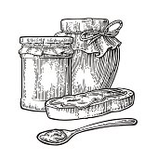
2 Cups of La Farrin (flour)
1 Tablespoon of Pihkasiķan (baking powder)
¼ Teaspoon of Sîwihtâķan (salt)
1 Tablespoon Sôķân (sugar)
¼ Cup Lôwil (oil)
1 Cup of Nipî (water)

Mix all the ingredients together.
Bake in the oven @ 400$°$ for 20 minutes.


Laķalet - Bannock

Ingredients:

2 Cups of La Farrin (flour)
1 Tablespoon of Pihkasiķan (baking powder)
¼ Teaspoon of Sîwihtâķan (salt)
1 Tablespoon Sôķân (sugar)
¼ Cup Lôwil (oil)
1 Cup of Nipî (water)

Mix all the ingredients together.
Bake in the oven @ 400$°$ for 20 minutes.

