AGENDA

FOR THE REGULAR MEETING
OF THE NORTHWEST SCHOOL DIVISION NO. 2O3
BOARD OF EDUCATION

DATE: | January 9, 2025 | LOCATION: | Northwest School Division  Boardroom
TIME: | 10:00 a.m. CST | LOCATION: | Northwest School Division  Boardroom

1. | Call to Order
2. | Additions to and Adoption of Agenda
3 | Adoption of Minutes of Last Meetings
Organizational Meeting – November 27, 2024
Regular Meeting – November 27, 2024
4. | Delegation
 | 4.1 | Facilities Presentation – Bob Tough
5. | Discussion / Decision Items
 | 5.1 | PMR Plan Amendment
 | 5.2 | Academic Calendar 2025-2026
 | 5.3 | 15-Passenger Vans Request
 | 5.4 | Public Section
 | 5.5 | Strategic Planning 2025
 | 5.5 | Financial Reports – November
 | 5.6 | Financial Reports – December
6. | Information Items
 | 6.1 | Celebrations
 | 6.2 | Calendar
7. | Closed Session
 | 7.1 | HR Report
 | 7.2 | Sector Update
 | 7.3 | Committee Reports
8. | Information of Emergent Items for Next Agenda
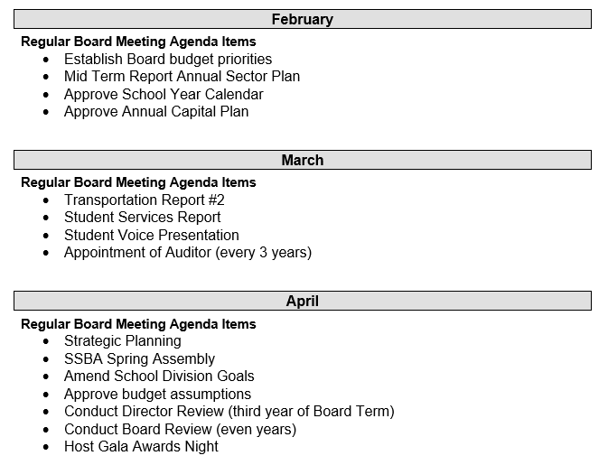

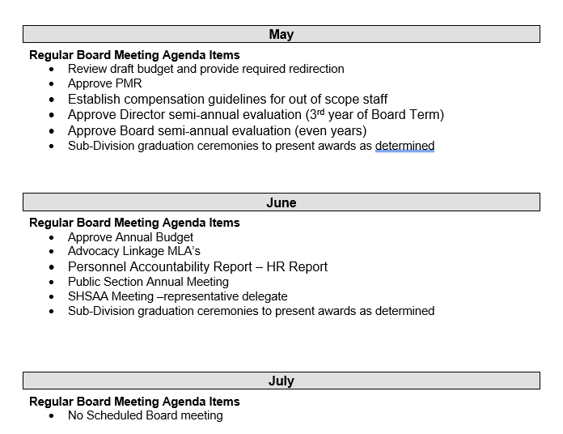

9. | Adjournment

MINUTES OF THE ORGANIZATIONAL MEETING OF THE BOARD OF EDUCATION OF THE NORTHWEST SCHOOL DIVISION NO. 203 HELD TUESDAY, NOVEMBER 27, 2024 AT 10:00 A.M. IN THE BOARD OFFICE AT MEADOW LAKE, SASKATCHEWAN VIA TEAMS

Members Present: Travis Neufeld, Kim Russell, Amanda McGowan, Rick Starnes, Cheyenne Ludwig, Laurel Pauls, Kristen McGowan, Vaughn Bellin, Barb Seymour, Patricia Main

Members Absent: Dr. James McKee

In Attendance: Duane Hauk, CEO
Michelle Pickett, CFO
Davin Hildebrand, Deputy Director of Education
Jennifer Williamson, Deputy Director of Education
Cheryl Treptow, Superintendent of Learning
Dawn Paylor, Superintendent of Learning
Aaron Oakes, Supt. Curriculum & Instruction
Kaitlin Harman, Communications Officer

Director of Education, Duane Hauk called the meeting to order.

Agenda  25-016 | Barb Seymour |  | That the agenda be adopted.  CARRIED
Chair |  |  | Duane Hauk opens nominations for Chair.
 | Patricia Main |  | Nominated Barb Seymour as Chair.
 | Cheyenne Ludwig |  | Nominated Kristen McGowan as Chair.
Chair Cease  25-017 | Vaughn Bellin |  | That nominations cease.  CARRIED
 |  |  | Barb Seymour was elected Chair.
Vice-Chair |  |  | Barb Seymour opens nominations for Vice-Chair.
 | Amanda McGowan | Nominated Cheyenne Ludwig as Vice-Chair
 | Rick Starnes | Nominated Patricia Main as Vice-Chair
Vice-Chair Cease  25-018 | Travis Neufeld | That nominations cease.  CARRIED
 |  |  | Patricia Main was elected Vice-Chair.
Board Committees  25-019 | Barb Seymour |  | That the following Board Committees be established for the upcoming year:  - Professional Development/Trustee Growth  - Policy Review/Governance  - Transportation  - Ad Hoc/Special Issues  CARRIED
Regular Board Meetings  25-020 | Rick Starnes |  | That the regular Board meeting be held in the Meadow Lake office on the second Thursday of each month starting at 10:00 AM, beginning in January 2025.  CARRIED
Indemnities and Expenses  25-021 | Cheyenne Ludwig |  | That the following indemnity and expense rates be established:  - Per Diem - equal to 1/197th of Class IV, Step 4 of the Teacher’s Collective Bargaining Agreement  - Mileage - $0.5724 per km  - Meals - $15/$20/$30  - Private Accommodations - $35 per night  - Travel Time - $20 per hour  - Communication - $35 per month  Definition of a day: six (6) hours or more per day  CARRIED
Signing Authorities  25-022 | Vaughn Bellin |  | That the signing authorities for the Northwest School Division No. 203 be the Board Chair or the Vice-Chair and the CFO or the CEO.  CARRIED
Adjournment  25-023 | Amanda McGowan |  | That we adjourn.  CARRIED  Time: 11:01 a.m.

__________________________ ___________________________
Barb Seymour, Chair Michelle Pickett, Chief Financial Officer

MINUTES OF THE REGULAR MEETING OF THE BOARD OF EDUCATION OF THE NORTHWEST SCHOOL DIVISION NO. 203 HELD TUESDAY, NOVEMBER 27, 2024, AT 11:02 A.M. IN THE BOARD OFFICE AT MEADOW LAKE, SASKATCHEWAN VIA TEAMS

Members Present: Barb Seymour, Chair
Patricia Main, Vice-Chair
Travis Neufeld, Kim Russell, Amanda McGowan, Rick Starnes, Cheyenne Ludwig, Laurel Pauls, Kristen McGowan, Vaughn Bellin

Members Absent: Dr. James McKee

In Attendance: Duane Hauk, CEO
Michelle Pickett, CFO
Davin Hildebrand, Deputy Director of Education
Jennifer Williamson, Deputy Director of Education
Cheryl Treptow, Superintendent of Learning
Dawn Paylor, Superintendent of Learning
Aaron Oakes, Superintendent of Schools
Kaitlin Harman, Communications Officer

Agenda  25-024 | Travis Neufeld | That the agenda be adopted.  CARRIED
Minutes  25-025 | Patricia Main | That the minutes of the October 10, 2024, regular meeting be approved as presented.  CARRIED
Delegation |  | The Board heard a presentation from Derek Sieben, External Auditor from Vantage CPA, regarding the 2023-2024 draft Audited Financial Statements.
Delegation |  | The Board met with the Transportation Officer, Virginia  Calvert, to review the operations of the Transportation Department.
Annual Report  25-026 | Patricia Main | That the 2023-2024 Annual Report for the Northwest School Division #203 be accepted and submitted to the Ministry of Education pending format approval and any significant changes.  CARRIED
Audited Financial Statements  25-027 | Patricia Main | That the draft Audited Financial Statements for 2023-2024 be accepted and submitted to the Provincial Comptroller and the Ministry of Education pending format approval and any significant changes.  CARRIED
Finance Statement  25-028 | Rick  Starnes | That the Financial Report for the period ending October 31, 2024, be approved as presented.  CARRIED
Closed Session  25-029 | Barb Seymour | That we enter a Closed Session.  CARRIED
Report from Closed Session  25-030 | Barb Seymour | That we rise and report from the Closed Session.  CARRIED
Emergent Items |  | - Facilities Department Presentation  - Draft 2025-2026 School Year Calendar Options
Adjournment  25-031 | Vaughn Bellin | That we adjourn.  CARRIED  Time: 2:43 p.m.

__________________________ ___________________________
Barb Seymour, Chair Michelle Pickett, Chief Financial Officer

4.1: Facilities Presentation

MEETING DATE: |  | January 9, 2025
FORUM |  |  | AGENDA ITEMS |  |  |  | INTENT
x | Board Meeting |  |  | Correspondence |  |  | X | Information
 | Committee of the Whole |  |  | New Business |  |  |  | Decision
 |  |  |  | Reports from Administrative Staff |  |  |  | Discussion
 |  |  | X | Other: Delegations
BACKGROUND
Bob Tough will be presenting on Maintenance and Facilities

CURRENT STATUS
FINANCIAL IMPLICATION
PREPARED BY: |  |  |  |  | DATE |  | ATTACHMENTS
 |  |  |  |  |  |  | 3 attachments
RECOMMENDATION

Capital Application Information

Capital Application Information
When submitting your applications, please note the following:
- Projects over $10 million qualify for the Major Capital Program.
- Projects between $1 and $10 million, that can be completed in a one- to two-year time frame, qualify for the Minor Capital Renewal Program. Given recent cost escalations, some minor capital applications may need to be reconsidered as major capital applications.
- School divisions are allowed to submit up to three applications for the Major Capital Program and up to two applications for the Minor Capital Renewal Program. The same capital project/school cannot be submitted through both programs.
- Only one school (unless it involves a school amalgamation) may be submitted per application. Multi-school renovations are not eligible for funding.
- For proposed new schools, please include projected enrolments of nearby schools assuming the new school is not built. A separate section has been added to forecast enrolment size specifically for new schools. For replacement schools, include the projected enrolment of the current school.
**The Ministry has stated in the past that if we do not provide 3rd party business cases, we will more than likely not receive any capital funding.

Major Capital Recommendations
- TPEC - New school attached onto new city arena/field house (no business case)
- Maidstone - New PreK to 12 school (Replace both Ratushniak and Maidstone High)
- Jubilee/Lakeview - New PreK to 4 school (Replace both Jubilee and Lakeview Schools)

Minor Capital Recommendations
- Green Acre - Major renovation to address FCI rating (no business case)
- Lashburn High - Major renovation to address FCI rating / business case costs

Building Information Summary
The document provides a detailed review of the capital requirements for several schools, highlighting their current conditions, enrolment statistics, and future needs.
- Green Acre School: Green Acre School, built in 1956 with an addition in 1994, has a 2024/25 enrolment of 55 students and is 63% utilized. The school faces issues such as an aging building, a high FCI rating, and the lack of a gymnasium, necessitating significant capital investment or replacement.
- H. Hardcastle School: H. Hardcastle School, established in 1965 with several additions, has an enrolment of 198 students and is 80% utilized. The school has elevation and water system issues, asbestos presence, and a projected FCI rating of 31.6% by 2030, requiring substantial renovations or replacement.
- JH Moore School: JH Moore School, built in 1961 with subsequent additions, has 164 students enrolled and is 66% utilized. The school contends with drainage issues, structural settling, and asbestos, with an FCI rating of 34.4% projected for 2030, necessitating significant repairs or a new facility.
- Jubilee School: Jubilee School, established in 1966 with an addition in 1980, has a 2024/25 enrolment of 240 students and is 66% utilized. The school faces asbestos flooring issues and outdated HVAC systems, with an FCI rating of 45.4% by 2030, requiring extensive renovations or a new school.
- Lakeview School: Lakeview School, built in 1972, has an enrolment of 327 students and is 79% utilized. The school requires entrance slab repairs, HVAC updates, and asbestos abatement, with an FCI rating of 41% by 2030, indicating the need for major renovations or replacement.
- Pierceland School: Pierceland School, established in 1960 with several additions, has 212 students enrolled and is 75% utilized. The school has elevation concerns, HVAC issues, and asbestos, with an FCI rating of 31% by 2030, necessitating significant capital investment or replacement.
- Ratushniak School: Ratushniak School, built in 1960 with additions in 1987 and 2020, has 190 students enrolled and is 69% utilized. The school faces layout design issues, ongoing bat problems, and asbestos, with an FCI rating of 31.1% by 2030, requiring substantial renovations or a new facility.

CAPITAL REVIEW 2025
Using the Ministry data from the 2021 audits, we have 8 schools that will fall into the critical range by 2030.
I will provide a brief description for each of the 8 sites as well as Lashburn High and Maidstone High (as they are a part of our current Capital Requests) below:

Green Acre:
- Built in 1956 with an addition completed in 1994.
- Enrolment is 55 students, 63% utilized (room for 32 additional students – 100%).
- New roof system over the original portion was completed in 2019.

Options:
- Continue as present, utilize PMR and minor renovation funding to extend the life expectancy and address Health & Safety items, school priorities etc.
- Minor Capital Application – request funds to address approx. $1.7 million in deficiencies in 2030.
- Major Capital – request funds for a new school
- Hold off improvements until school needs replacement, shut the school down and relocate students to other schools as required.

Concerns:
- Age of original building – 1956
- FCI Rating of 50.5% in 2030 (cost of $1.17 million)
- Sewer system – current process requires monthly removal of all sewage. No community septic system.
- No gymnasium – NWSD rents community hall for gym activities.

H. Hardcastle:
- Original School was built in 1965 with an addition in 1973, 1976, 1984 and 2000.
- Enrolment is 198 students, 80% utilized (room for an additional 49 students – 100%)
- We have upgraded some roofing in recent years along with new boilers and RTU (roof top units).
- Recent IA renovation to include proper dust collection and a welding booth.

Options:
- Continue as present, utilize PMR and minor renovation funding to extend the life expectancy and address Health & Safety items, school priorities etc.
- Minor Capital Application – request funds to address approx. $5.3 million in deficiencies in 2030.
- Major Capital – request funds for a new school.
- Hold off improvements until school needs replacement.

Concerns:
- Elevation changes – we have 3 sections of the school to which handicap students would not have access. The basement has the high school main washrooms, 2 classrooms and Industrial Arts Lab. The upstairs (above the basement) has 2 classrooms and the Home Economics Lab. The other side of the school (Gymnasium) has 2 classrooms on the second floor as well. We currently have no lifts in this school.
- Water System – the Village of Edam does not have its own drinking water supply system. Edam school currently operates 2 sand point wells. Generally, these have not posed any issues but recently we have had failed water tests for the gymnasium well (showers/toilets etc). We have made some modifications, and our most recent test has passed. We did have concerns of running out of water a few years back when it was dry – this may come into play again if we don’t end up with snow and run off.
- Asbestos – We have identified some asbestos on site. We have done some abatement, but more is needed (pipe fittings, flooring, drywall mud, vermiculite).
- FCI Rating of 31.6% in 2030 (Cost of $5.32 million).

JH Moore:
- Original School was built in 1961 with an addition in 1985 and 2017.
- Enrolment is 164 students, 66% utilized (room for an additional 85 students – 100%)
- We have upgraded some roofing in recent years. School has a recent HVAC upgrade with Change Airs in every classroom and a standalone gym HVAC unit.
- Recent landscape work around the perimeter to try and promote better drainage was done in 2023.
- Town has recently tied into Lloydminster water system.
- Plans to paint the exterior of the school this spring/summer.

Options:
- Continue as present, utilize PMR and minor renovation funding to extend the life expectancy and address Health & Safety items, school priorities etc.
- Minor Capital Application – request funds to address approx. $3.3 million in deficiencies in 2030.
- Major Capital – request funds for a new school or look at a new combined K-12 school.
- Hold off improvements until school needs replacement.

Concerns:
- Drainage – this has been a concern recently. The inability to get water to run away from the building has caused flooring issues in some rooms (new flooring program started in 2023).
- Settling – we have a small addition on the west side that has been inspected by an engineer. It appears that this was added on after the original construction and did not have adequate piles or supports underneath it. We are currently monitoring joint cracks etc.
- Asbestos – We have identified asbestos in the gym area drywall mud and a small area of flooring remains.
- FCI Rating of 34.4% in 2030 (cost of $3.35 million).

Jubilee:
- Original School was built in 1966 with an addition in 1980.
- Enrolment is 240 students, 66% utilized (room for an additional 123 students – 100%)
- We have upgraded some roofing in recent years.
- We installed a few Change Airs recently and a standalone gym HVAC unit.
- We upgraded both the natural gas and power service feeding the school (3 phase power).
- Recent landscape work around the perimeter to try and promote better drainage was completed a few years ago.
- Recent roof truss replacement was required over the front entrance. A second roof was built over an existing and we had roof drains that had come apart that no one detected which caused structural damages.
- Plans to continue Herman Nelson (HVAC) replacement with Change Airs moving forward.

Options:
- Continue as present, utilize PMR and minor renovation funding to extend the life expectancy and address Health & Safety items, school priorities etc.
- Minor Capital Application – request funds to address approx. $4.6 million in deficiencies in 2030.
- Major Capital – request funds for a new school or look at a new combined PreK to 4 school.
- Hold off improvements until school needs replacement

Concerns:
- Asbestos flooring – this school has a large amount of asbestos flooring. We have removed some in the past and will continue to monitor and remove as required moving forward.
- HVAC – old, outdated Herman Nelson heating units are still an issue – we are making plans to replace these units over the next few years. The removal of the units allows us to remove parts for other units within the school.
- FCI Rating of 45.4% in 2030 (cost of $4.6 million).

Lakeview:
- Original School was built in 1972.
- Enrolment is 327 students, 79% utilized (room for an additional 87 students – 100%)
- We have upgraded most of the roofing in recent years (Stimulus funds).
- Recent slab / structural support corrections have been made.

Options:
- Continue as present, utilize PMR and minor renovation funding to extend the life expectancy and address Health & Safety items, school priorities etc.
- Minor Capital Application – request funds to address approx. $6.06 million in deficiencies in 2030.
- Major Capital – request funds for a new school or look at a new combined PreK to 4 school.
- Hold off improvements until school needs replacement.

Concerns:
- HVAC – Boiler and air handlers will require some funding for replacement in the next few years.
- Asbestos – we have identified some flooring in the gym service areas as well as roof drain piping.
- FCI Rating of 41% in 2030 (cost of $6.06 million).

Pierceland:
- Original School was built in 1960 with an addition in 1973, 1984, 1995, 2011 and 2017.
- Enrolment is 212 students, 75% utilized (room for an additional 72 students – 100%)
- Recent IA Renovation / Dust collection system
- Plans to upgrade HVAC units with Change Air units (phase 1 completed this year)
- Science Lab renovation has started
- Plans to perform some roof repairs to try and extend the life expectancy.

Options:
- Continue as present, utilize PMR and minor renovation funding to extend the life expectancy and address Health & Safety items, school priorities etc.
- Minor Capital Application – request funds to address approx. $5.23 million in deficiencies in 2030.
- Major Capital – request funds for a new school.
- Hold off improvements until school needs replacement.

Concerns:
- Elevation concerns with the school requires 2 lifts, this is not ideal for any handicap students or staff members. Changerooms are located upstairs in the gymnasium.
- HVAC – Boiler and air handlers will require some funding for replacement in the next few years.
- Asbestos – We have identified vermiculite, pipe fittings and wall board that all contain asbestos.
- FCI Rating of 31% in 2030 (cost of $5.23 million).

Ratushniak:
- Built in 1960 with an addition in 1987 and 2020.
- Enrolment is 190 students, 69% utilized (room for an additional 83 students – 100%)
- Recent addition in 2020.
- New suspended ceiling and lighting in west corridor.
- Plan to paint exterior this spring/summer.

Options:
- Continue as present, utilize PMR and minor renovation funding to extend the life expectancy and address Health & Safety items, school priorities etc.
- Minor Capital Application – request funds to address approx. $3.19 million in deficiencies in 2030.
- Major Capital – request funds for a new school or new combined PreK to 12 school (current request).
- Hold off improvements until school needs replacement.

Concerns:
- Poor layout design with connection between the schools being a gymnasium.
- Ongoing bat issues that we have been able to address year to year.
- Asbestos – we have identified asbestos in some flooring, roof drain piping, chalkboards, wall board and vermiculite in walls.
- FCI Rating of 31.1% in 2030 (cost of $3.19 million).

TPEC (Transition Place Education Centre):
- Built in 1961 with a renovation in 1994.
- Enrolment is 89 students, 74% utilized (room for an additional 31 students – 100%)
- New kitchen cupboards installed this year.

Options:
- Continue as present, utilize PMR and minor renovation funding to extend the life expectancy and address Health & Safety items, school priorities etc.
- Minor Capital Application – request funds to address approx. $1.15 million in deficiencies in 2030.
- Major Capital – request funds for a new school (Current application)

Concerns:
- School programming requires outside rentals due to footprint of existing school.
- Building was a former office, and the layout is not ideal for class sizes etc.
- Asbestos – We have abated all asbestos flooring, but the school still has asbestos in the drywall mud, a few pipe fittings and vermiculite.
- HVAC will require upgrades as the furnaces are past their useful life expectancy.
- FCI Rating of 37.1% in 2030 (cost of $1.15 million).

Lashburn High School:
- Built in 1960 with an addition in 1986.
- Enrolment is 141 students, 45% utilized (room for an additional 171 students – 100%)
- Recent roof replacement – majority of roofing completed in 2023.
- IA Renovation completed in 2024.
- Gym floor was recently replaced through insurance.

Options:
- Continue as present, utilize PMR and minor renovation funding to extend the life expectancy and address Health & Safety items, school priorities etc.
- Minor Capital Application – request funds to address approx. $4.89 million in deficiencies in 2030 (Current request).
- Major Capital – request funds for a new school or new combined PreK to 12 school.
- Hold off improvements until school needs replacement.

Concerns:
- HVAC concerns – we have replaced 2 sets of boilers to date. We still have another set to replace along with the 2 main air handling units. We have been hiring 3rd parties to come in and work on these to keep them operational.
- Drainage – we have had some issues with drainage in the past. We have taken some corrective action, and it appears that we may have a handle on this.
- FCI Rating of 28.4% in 2030 (cost of $4.89 million). Although this does not reach a critical FCI rating, it still requires almost $5 million in funding to address the identified deficiencies.

Maidstone High School:
- Built in 1971 with an addition in 1990.
- Enrolment is 202 students, 68% utilized (room for an additional 97 students – 100%)
- Recent roof replacement – majority of roofing completed in 2023 (only metal roofing remains which we believe has a lot of years left in it).
- IA Renovation completed in 2022/23.
- Gym floor was recently replaced through insurance.
- Gym HVAC recently upgraded.

Options:
- Continue as present, utilize PMR and minor renovation funding to extend the life expectancy and address Health & Safety items, school priorities etc.
- Minor Capital Application – request funds to address approx. $4.04 million in deficiencies in 2030 (Current request).
- Major Capital – request funds for a new school or new combined Pre-k to 12 school (Current request).
- Hold off improvements until school needs replacement.

Concerns:
- HVAC concerns – Boilers had been replaced a few years back, but we still struggle with the 2 air handlers located within the school. We have brought in a few 3rd parties to try and address issues and to ensure proper operation. This tends to be an annual issue that will at some point require replacement.
- Bats – we have had past issues with bats, but it appears that they have transitioned to Ratushniak.
- Asbestos – We have abated all asbestos flooring except the Home Ec. lab. We also have a few pipe fittings in the one mechanical room.
- FCI Rating of 25% in 2030 (cost of $4.04 million). Although this does not reach a critical FCI rating, it still requires $4 million in funding to address the identified deficiencies.

5.1: PMR Plan Amendment

MEETING DATE: |  | Jan 9, 2025
FORUM |  |  | AGENDA ITEMS |  |  |  | INTENT
x | Board Meeting |  |  | Correspondence |  |  | x | Information
 | Committee of the Whole |  |  | New Business |  |  | x | Decision
 |  |  | x | Reports from Administrative Staff |  |  | x | Discussion
 |  |  |  | Other: Delegations
BACKGROUND
The Ministry has requested that all school divisions submit a 3-year plan pertaining to Preventative Maintenance and Renewal. The plan is to be based on information entered into the AssetPlanner software program.

CURRENT STATUS
The Ministry requires that changes to the approved 3-year plan are submitted on a PMR Plan Amendment form. An emergent issue has been identified that need to be included in the 2025 phase of the approved plan. The project was not included in the 3-year plan approved by the Board in May 2024 that included the 2024-25 school year. A Board motion is required to submit the plan amendment.

PROS AND CONS
N/A

FINANCIAL IMPLICATION
The total cost of the identified projects is estimated at $60,000. Funds will be taken from existing PMR dollars that were being held as a contingency fund.

PREPARED BY: |  |  |  |  | DATE |  | ATTACHMENTS
Michelle Pickett |  |  |  |  | December 31, 2024 |  | Two
RECOMMENDATION

That the proposed PMR plan amendment be approved as requested and submitted to the Ministry of Education.

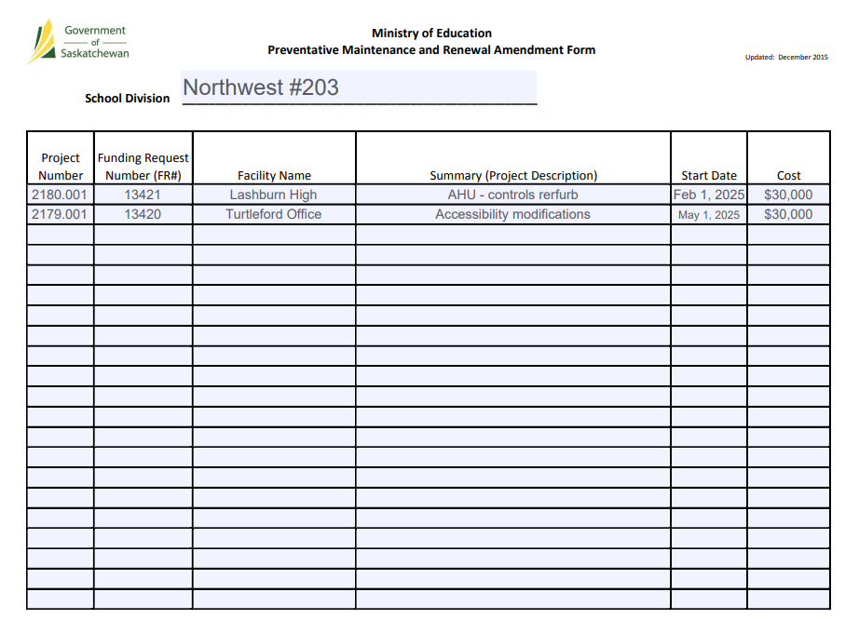

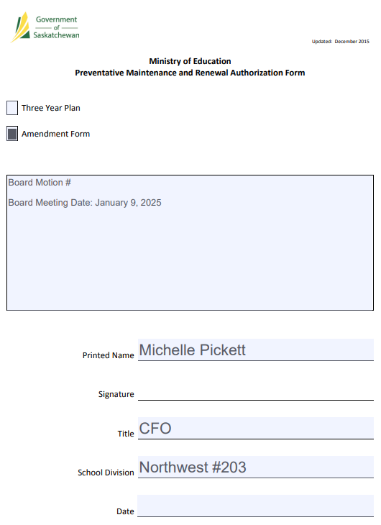

5.2: Academic Calendar 2025-2026

MEETING DATE: |  | January 9, 2025
FORUM |  |  | AGENDA ITEMS |  |  |  | INTENT
x | Board Meeting |  |  | Correspondence |  |  |  | Information
 | Committee of the Whole |  |  | New Business |  |  | x | Decision
 |  |  | x | Reports from Administrative Staff |  |  |  | Discussion
 |  |  |  | Other: Delegations
BACKGROUND
A calendar committee consisting of 3 LEADS members and 3 NWTA members develop draft calendar choices for Board approval. In previous years the Board may approve multiple calendars and allow division staff to vote on their preferred choice. The Board of Education has the final decision to approve the school academic calendar.

CURRENT STATUS
The Calendar Committee has developed 3 calendar options. The Board will determine which options presented are to be considered for voting by staff.

PROS AND CONS
FINANCIAL IMPLICATION
PREPARED BY: |  |  |  |  | DATE |  | ATTACHMENTS
Duane Hauk |  |  |  |  | December 31, 2024 |  | 3 Calendars
RECOMMENDATION

August ‘25 |  |  |  |  |  |  |  |  |  | February ‘26
Su | M | Tu | W | Th | F | Sa |  |  |  | Su | M |  |  |  | Tu |  | W |  |  | Th |  |  | F |  |  | Sa
 |  |  |  |  | 1 | 2 |  |  |  | 1 | 2 |  |  |  | 3 |  | 4 |  |  | 5 |  |  | 6 |  |  | 7
3 | 4 | 5 | 6 | 7 | 8 | 9 |  |  |  | 8 | 9 |  |  |  | 10 |  | 11 |  |  | 12 |  |  | 13 |  |  | 14
10 | 11 | 12 | 13 | 14 | 15 | 16 | 0/5 |  |  | 15 | 16  Family |  |  |  | 17 |  | 18 |  |  | 19 |  |  | 20 |  |  | 21
17 | 18 | 19 | 20 | 21 | 22 | 23 | 15 |  |  | 22 | 23 |  |  |  | 24 |  | 25 |  |  | 26 |  |  | 27 |  |  | 28
24 | 25  Admin | 26  Staff | 27  PD | 28  Conf | 29  PD | 30
31
September ‘25 |  |  |  |  |  |  |  |  |  | March ‘26
Su | M | Tu | W | Th | F | Sa |  |  |  | Su | M |  |  |  | Tu |  | W |  |  | Th |  |  | F |  |  | Sa
 | 1  Labour Day | 2  START | 3 | 4 | 5 | 6 | 23* |  |  | 1 | 2 |  |  |  | 3 |  | 4  PD 65mins |  |  | 5 |  |  | 6 |  |  | 7
7 | 8 | 9 | 10 | 11 | 12 | 13 |  |  |  | 8 | 9 |  |  |  | 10 |  | 11 |  |  | 12 |  |  | 13 |  |  | 14
14 | 15 | 16 | 17 | 18 | 19 | 20 |  |  |  | 15 | 16 |  |  |  | 17 |  | 18 |  |  | 19 |  |  | 20 |  |  | 21
21 | 22 | 23 | 24  PD 65mins | 25 | 26 | 27 | 21 |  |  | 22 | 23 |  |  |  | 24 |  | 25 |  |  | 26 |  |  | 27 |  |  | 28
28 | 29 | 30  T&R |  |  |  |  |  |  |  | 29 |  | 30 |  | 31
October ‘25 |  |  |  |  |  |  |  |  |  | April ‘26
Su | M | Tu | W | Th | F | Sa |  |  |  | Su | M |  |  |  | Tu |  | W |  |  | Th |  |  | F |  |  | Sa
 |  |  | 1 | 2 | 3 | 4 |  |  |  |  |  |  |  |  |  |  | 1 |  |  | 2 |  |  | 3  Good Friday |  |  | 4
5 | 6 | 7 | 8 | 9 | 10 | 11 | 16 |  |  | 5  Easter | 6  Easter Mon |  |  |  | 7 |  | 8 |  |  | 9 |  |  | 10 |  |  | 11
12 | 13  Thanksgiving | 14 | 15 | 16 | 17 | 18 |  |  |  | 12 | 13 |  |  |  | 14* |  | 15* |  |  | 16 |  |  | 17 |  |  | 18
19 | 20 | 21 | 22  PD 65mins | 23 | 24 | 25 | 22 |  |  | 19 | 20 |  |  |  | 21 |  | 22 |  |  | 23 |  |  | 24 |  |  | 25
26 | 27 | 28 | 29 | 30 | 31 |  |  |  |  | 26 | 27 |  |  |  | 28 |  | 29  PD 65mins |  |  | 30
November ‘25 |  |  |  |  |  |  |  |  |  | May ‘26
Su | M | Tu | W | Th | F | Sa |  |  |  | Su | M |  |  |  | Tu |  | W |  |  | Th |  |  | F |  |  | Sa
 |  |  |  |  |  | 1 |  |  |  |  |  |  |  |  |  |  |  |  |  |  |  |  | 1 |  |  | 2
2 | 3 | 4* | 5* | 6 | 7  PD | 8 | 20 |  |  | 3 | 4 |  |  |  | 5 |  | 6 |  |  | 7 |  |  | 8 |  |  | 9
9 | 10  Sch Holiday | 11  R’brance | 12 | 13 | 14 | 15 | 18/19* |  |  | 10 | 11 |  |  |  | 12 |  | 13 |  |  | 14 |  |  | 15  SCH holiday |  |  | 16
16 | 17 | 18 | 19 | 20 | 21 | 22 |  |  |  | 17 | 18  Victoria |  |  |  | 19 |  | 20 |  |  | 21 |  |  | 22 |  |  | 23
23 | 24 | 25 | 26  PD 65mins | 27 | 28 | 29 |  |  |  | 24 | 25 |  |  |  | 26 |  | 27 |  |  | 28 |  |  | 29 |  |  | 30
30 |  |  |  |  |  |  |  |  |  | 31
December ‘25 |  |  |  |  |  |  |  |  |  | June ‘26
Su | M | Tu | W | Th | F | Sa |  |  |  | Su | M |  |  |  | Tu |  | W |  |  | Th |  |  | F |  |  | Sa
 | 1 | 2 | 3 | 4 | 5 | 6 |  |  |  |  | 1 |  |  |  | 2 |  | 3 |  |  | 4 |  |  | 5 |  |  | 6
7 | 8 | 9 | 10 | 11 | 12 | 13 | 19/20 |  |  | 7 | 8 |  |  |  | 9 |  | 10 |  |  | 11 |  |  | 12 |  |  | 13
14 | 15 | 16 | 17 | 18 | 19 | 20 | 15 |  |  | 14 | 15 |  |  |  | 16 |  | 17 |  |  | 18 |  |  | 19 |  |  | 20
21 | 22 | 23 | 24 | 25  Xmas | 26  Boxing | 27 |  |  |  | 21 | 22  Exams |  |  |  | 23  Exams |  | 24  Exams |  |  | 25  Exams |  |  | 26  ADMIN |  |  | 27
28 | 29 | 30 | 31 |  |  |  |  |  |  | 28 | 29  No school |  |  |  | 30  No school
January ‘26
Su | M | Tu | W | Th | F | Sa |  |  |  | *P/S/T
 |  |  |  | 1  New Yrs | 2 | 3 | 19/20 |  |  |  |  |  |  |  | 1 = Convention
4 | 5 | 6 | 7 | 8 | 9 | 10 |  |  |  |  |  |  |  |  | 2 = Admin
11 | 12 | 13 | 14 | 15 | 16 | 17 | Teacher Days = 195 |  |  |  |  |  |  |  | 1 = Staff
18 | 19 | 20 | 21 | 22 | 23 | 24 |  |  |  |  |  |  |  |  | 3 = PD + 8hrs
25 | 26  Exams | 27  Exams | 28  Exams | 29  Exams | 30  Turn Around | 31 | Student Days = 187 |  |  |  |  |  |  |  | 1= Turn Around

WEDNESDAY PD IS AFTER SCHOOL
*PD DAYS ARE DIVISION DIRECTED
PD 5 days at 65 minutes after school: Sept 24; Oct 22; Nov 26; March 4; April 29
Option 1

August ‘25 |  |  |  |  |  |  |  |  |  | February ‘26
Su | M | Tu | W | Th | F | Sa |  |  |  | Su | M |  |  |  | Tu |  | W |  |  | Th |  |  | F |  |  | Sa
 |  |  |  |  | 1 | 2 |  |  |  | 1 | 2 |  |  |  | 3 |  | 4 |  |  | 5 |  |  | 6 |  |  | 7
3 | 4 | 5 | 6 | 7 | 8 | 9 |  |  |  | 8 | 9 |  |  |  | 10 |  | 11 |  |  | 12 |  |  | 13 |  |  | 14
10 | 11 | 12 | 13 | 14 | 15 | 16 | 0/5 |  |  | 15 | 16  Family |  |  |  | 17 |  | 18 |  |  | 19 |  |  | 20 |  |  | 21
17 | 18 | 19 | 20 | 21 | 22 | 23 | 15 |  |  | 22 | 23 |  |  |  | 24 |  | 25  Early/PD |  |  | 26 |  |  | 27 |  |  | 28
24 | 25  Admin | 26  Staff | 27  PD | 28  Conf | 29  PD | 30
31
September ‘25 |  |  |  |  |  |  |  |  |  | March ‘26
Su | M | Tu | W | Th | F | Sa |  |  |  | Su | M |  |  |  | Tu |  | W |  |  | Th |  |  | F |  |  | Sa
 | 1  Labour Day | 2  START | 3 | 4 | 5 | 6 | 22 |  |  | 1 | 2 |  |  |  | 3 |  | 4 |  |  | 5 |  |  | 6 |  |  | 7
7 | 8 | 9 | 10 | 11 | 12 | 13 |  |  |  | 8 | 9 |  |  |  | 10 |  | 11 |  |  | 12 |  |  | 13 |  |  | 14
14 | 15 | 16 | 17 | 18 | 19 | 20 |  |  |  | 15 | 16 |  |  |  | 17 |  | 18 |  |  | 19 |  |  | 20 |  |  | 21
21 | 22 | 23 | 24  Early/PD | 25 | 26 | 27 | 21 |  |  | 22 | 23 |  |  |  | 24 |  | 25  Early/PD |  |  | 26 |  |  | 27 |  |  | 28
28 | 29 | 30  T&R |  |  |  |  |  |  |  | 29 |  | 30 |  | 31
October ‘25 |  |  |  |  |  |  |  |  |  | April ‘26
Su | M | Tu | W | Th | F | Sa |  |  |  | Su | M |  |  |  | Tu |  | W |  |  | Th |  |  | F |  |  | Sa
 |  |  | 1 | 2 | 3 | 4 |  |  |  |  |  |  |  |  |  |  | 1 |  |  | 2 |  |  | 3  Good Friday |  |  | 4
5 | 6 | 7 | 8 | 9 | 10 | 11 | 17* |  |  | 5  Easter | 6  Easter Mon |  |  |  | 7 |  | 8 |  |  | 9 |  |  | 10 |  |  | 11
12 | 13  Thanksgiving | 14 | 15 | 16 | 17 | 18 |  |  |  | 12 | 13 |  |  |  | 14* |  | 15* |  |  | 16 |  |  | 17 |  |  | 18
19 | 20 | 21 | 22 | 23 | 24 | 25 | 22 |  |  | 19 | 20 |  |  |  | 21 |  | 22 |  |  | 23 |  |  | 24 |  |  | 25
26 | 27 | 28 | 29  Early/PD | 30 | 31 |  |  |  |  | 26 | 27 |  |  |  | 28 |  | 29  Early/PD |  |  | 30
November ‘25 |  |  |  |  |  |  |  |  |  | May ‘26
Su | M | Tu | W | Th | F | Sa |  |  |  | Su | M |  |  |  | Tu |  | W |  |  | Th |  |  | F |  |  | Sa
 |  |  |  |  |  | 1 |  |  |  |  |  |  |  |  |  |  |  |  |  |  |  |  | 1 |  |  | 2
2 | 3 | 4 | 5 | 6 | 7 | 8 | 20 |  |  | 3 | 4 |  |  |  | 5 |  | 6 |  |  | 7 |  |  | 8 |  |  | 9
9 | 10  Holiday | 11  R’brance | 12 | 13 | 14 | 15 | 19* |  |  | 10 | 11 |  |  |  | 12 |  | 13 |  |  | 14 |  |  | 15 |  |  | 16
16 | 17 | 18 | 19* | 20* | 21 | 22 |  |  |  | 17 | 18  Victoria |  |  |  | 19 |  | 20 |  |  | 21 |  |  | 22 |  |  | 23
23 | 24 | 25 | 26  Early/PD | 27 | 28 | 29 |  |  |  | 24 | 25 |  |  |  | 26 |  | 27  Early/PD |  |  | 28 |  |  | 29 |  |  | 30
30 |  |  |  |  |  |  |  |  |  | 31
December ‘25 |  |  |  |  |  |  |  |  |  | June ‘26
Su | M | Tu | W | Th | F | Sa |  |  |  | Su | M |  |  |  | Tu |  | W |  |  | Th |  |  | F |  |  | Sa
 | 1 | 2 | 3 | 4 | 5 | 6 |  |  |  |  | 1 |  |  |  | 2 |  | 3 |  |  | 4 |  |  | 5 |  |  | 6
7 | 8 | 9 | 10 | 11 | 12 | 13 | 19/20 |  |  | 7 | 8 |  |  |  | 9 |  | 10 |  |  | 11 |  |  | 12 |  |  | 13
14 | 15 | 16 | 17 | 18 | 19 | 20 | 15 |  |  | 14 | 15 |  |  |  | 16 |  | 17 |  |  | 18 |  |  | 19 |  |  | 20
21 | 22 | 23 | 24 | 25  Xmas | 26  Boxing | 27 |  |  |  | 21 | 22  Exams |  |  |  | 23  Exams |  | 24  Exams |  |  | 25  Exams |  |  | 26  ADMIN |  |  | 27
28 | 29 | 30 | 31 |  |  |  |  |  |  | 28 | 29  No school |  |  |  | 30  No school
January ‘26
Su | M | Tu | W | Th | F | Sa |  |  |  | *P/S/T
 |  |  |  | 1  New Yrs | 2 | 3 | 19/20 |  |  |  |  |  |  |  | 1 = Convention
4 | 5 | 6 | 7 | 8 | 9 | 10 |  |  |  |  |  |  |  |  | 2 = Admin
11 | 12 | 13 | 14 | 15 | 16 | 17 | Teacher Days = 196 |  |  |  |  |  |  |  | 1 = Staff
18 | 19 | 20 | 21  Early/PD | 22 | 23 | 24 |  |  |  |  |  |  |  |  | 2 = PD + 8hrs
25 | 26  Exams | 27  Exams | 28  Exams | 29  Exams | 30  Turn Around | 31 | Student Days = 189 |  |  |  |  |  |  |  | 1= Turn Around (Sem 1)

WEDNESDAY PD – 1 HOUR EARLY DISMISSAL
FULL PD DAYS – DIVISION DIRECTED
Early dismissal – 8 days: Sept 24; Oct 29; Nov 26; Jan 21 (taking in account exams last week); Feb 25; March 25; April 29; May 27
Option 2

August ‘25 |  |  |  |  |  |  |  |  |  |  | February ‘26
Su | M | Tu | W | Th | F | Sa |  |  |  | Su |  | M |  |  | Tu |  |  | W |  |  | Th |  |  | F |  |  | Sa
 |  |  |  |  | 1 | 2 |  |  |  | 1 |  | 2 |  |  | 3 |  |  | 4 |  |  | 5 |  |  | 6 |  |  | 7
3 | 4 | 5 | 6 | 7 | 8 | 9 |  |  |  | 8 |  | 9 |  |  | 10 |  |  | 11 |  |  | 12 |  |  | 13 |  |  | 14
10 | 11 | 12 | 13 | 14 | 15 | 16 | 0/5 |  |  | 15 |  | 16  Family |  |  | 17 |  |  | 18 |  |  | 19 |  |  | 20 |  |  | 21
17 | 18 | 19 | 20 | 21 | 22 | 23 | 15 |  |  | 22 |  | 23 |  |  | 24 |  |  | 25 |  |  | 26 |  |  | 27 |  |  | 28
24 | 25  Admin | 26  Staff | 27  ProfDev | 28  Conf | 29  ProfDev | 30
31
September ‘25 |  |  |  |  |  |  |  |  |  |  | March ‘26
Su | M | Tu | W | Th | F | Sa |  |  |  | Su |  | M |  |  | Tu |  |  | W |  |  | Th |  |  | F |  |  | Sa
 | 1  Labour Day | 2  START | 3 | 4 | 5 | 6 | 22 |  |  | 1 |  | 2 |  |  | 3 |  |  | 4  ProfDev |  |  | 5 |  |  | 6 |  |  | 7
7 | 8 | 9 | 10 | 11 | 12 | 13 |  |  |  | 8 |  | 9 |  |  | 10 |  |  | 11 |  |  | 12 |  |  | 13 |  |  | 14
14 | 15 | 16 | 17 | 18 | 19 | 20 |  |  |  | 15 |  | 16 |  |  | 17 |  |  | 18 |  |  | 19 |  |  | 20 |  |  | 21
21 | 22 | 23 | 24  ProfDev | 25 | 26 | 27 | 21 |  |  | 22 |  | 23 |  |  | 24 |  |  | 25 |  |  | 26 |  |  | 27 |  |  | 28
28 | 29 | 30  T&R |  |  |  |  |  |  |  |  | 29 |  | 30 |  |  | 31
October ‘25 |  |  |  |  |  |  |  |  |  |  | April ‘26
Su | M | Tu | W | Th | F | Sa |  |  |  | Su |  | M |  |  | Tu |  |  | W |  |  | Th |  |  | F |  |  | Sa
 |  |  | 1 | 2 | 3 | 4 |  |  |  |  |  |  |  |  |  |  |  | 1 |  |  | 2 |  |  | 3  Good Friday |  |  | 4
5 | 6 | 7 | 8 | 9 | 10 | 11 | 17* |  |  | 5  Easter |  | 6  Easter Mon |  |  | 7 |  |  | 8 |  |  | 9 |  |  | 10 |  |  | 11
12 | 13  Thanksgiving | 14 | 15 | 16 | 17 | 18 |  |  |  | 12 |  | 13 |  |  | 14* |  |  | 15* |  |  | 16 |  |  | 17 |  |  | 18
19 | 20 | 21 | 22  ProfDev | 23 | 24 | 25 | 22 |  |  | 19 |  | 20 |  |  | 21 |  |  | 22 |  |  | 23 |  |  | 24 |  |  | 25
26 | 27 | 28 | 29 | 30 | 31 |  |  |  |  | 26 |  | 27 |  |  | 28 |  |  | 29  ProfDev |  |  | 30
November ‘25 |  |  |  |  |  |  |  |  |  |  | May ‘26
Su | M | Tu | W | Th | F | Sa |  |  |  | Su |  | M |  |  | Tu |  |  | W |  |  | Th |  |  | F |  |  | Sa
 |  |  |  |  |  | 1 |  |  |  |  |  |  |  |  |  |  |  |  |  |  |  |  |  | 1 |  |  | 2
2 | 3 | 4 | 5 | 6 | 7 | 8 | 20 |  |  | 3 |  | 4 |  |  | 5 |  |  | 6 |  |  | 7 |  |  | 8 |  |  | 9
9 | 10  Holiday | 11  R’brance | 12  No school | 13  No School | 14  No school | 15 | 16* |  |  | 10 |  | 11 |  |  | 12 |  |  | 13 |  |  | 14 |  |  | 15 |  |  | 16
16 | 17 | 18 | 19* | 20* | 21 | 22 |  |  |  | 17 |  | 18  Victoria |  |  | 19 |  |  | 20 |  |  | 21 |  |  | 22 |  |  | 23
23 | 24 | 25 | 26  ProfDev | 27 | 28 | 29 |  |  |  | 24 |  | 25 |  |  | 26 |  |  | 27 |  |  | 28 |  |  | 29 |  |  | 30
30 |  |  |  |  |  |  |  |  |  | 31
December ‘25 |  |  |  |  |  |  |  |  |  |  | June ‘26
Su | M | Tu | W | Th | F | Sa |  |  |  | Su |  | M |  |  | Tu |  |  | W |  |  | Th |  |  | F |  |  | Sa
 | 1 | 2 | 3 | 4 | 5 | 6 |  |  |  |  |  | 1 |  |  | 2 |  |  | 3 |  |  | 4 |  |  | 5 |  |  | 6
7 | 8 | 9 | 10 | 11 | 12 | 13 | 19/20 |  |  | 7 |  | 8 |  |  | 9 |  |  | 10 |  |  | 11 |  |  | 12 |  |  | 13
14 | 15 | 16 | 17 | 18 | 19 | 20 | 15 |  |  | 14 |  | 15 |  |  | 16 |  |  | 17 |  |  | 18 |  |  | 19 |  |  | 20
21 | 22 | 23 | 24 | 25  Xmas | 26  Boxing | 27 |  |  |  | 21 |  | 22  Exams |  |  | 23  Exams |  |  | 24  Exams |  |  | 25  Exams |  |  | 26  ProfDevV |  |  | 27
28 | 29 | 30 | 31 |  |  |  |  |  |  | 28 |  | 29  Admin |  |  | 30  Admin
January ‘26
Su | M | Tu | W | Th | F | Sa |  |  |  | *P/S/T
 |  |  |  | 1  New Yrs | 2 | 3 | 19/20 |  |  |  |  |  |  |  | 1 = Convention
4 | 5 | 6 | 7 | 8 | 9 | 10 |  |  |  |  |  |  |  |  | 3 = Admin
11 | 12 | 13 | 14 | 15 | 16 | 17 | Teacher Days = 195 |  |  |  |  |  |  |  | 1 = Staff
18 | 19 | 20 | 21 | 22 | 23 | 24 |  |  |  |  |  |  |  |  | 3 = PROFDEV + 8hrs
25 | 26  Exams | 27  Exams | 28  Exams | 29  Exams | 30  Turn Around | 31 | Student Days = 186 |  |  |  |  |  |  |  | 1= Turn Around (Sem 1)

WEDNESDAY PD IS AFTER SCHOOL
*PD DAYS ARE DIVISION DIRECTED
Option 3
Prof Dev - 5 days at 65 minutes: Sept 24; Oct 22; Nov 26; March 4; April 29

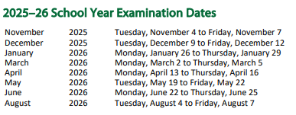

Q1 Sept 2 - Nov 7
Q2 Nov 10 - Jan 30
Q3 Feb 2 - April 17
Q4 April 20 - June 26

S1 Sept 2 - Jan 30
S2 Feb 1- June 26

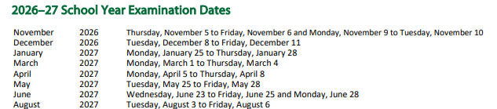

5.3: 15 Passenger Vans Request

MEETING DATE: |  | January 9, 2025
FORUM |  |  | AGENDA ITEMS |  |  |  | INTENT
x | Board Meeting |  |  | Correspondence |  |  |  | Information
 | Committee of the Whole |  | x | New Business |  |  |  | Decision
 |  |  |  | Reports from Administrative Staff |  |  | x | Discussion
 |  |  |  | Other: Delegations
BACKGROUND
Student transportation for extra curricular occurs with all schools frequently throughout the year. Past requests for 15 passenger vans have been denied due to safety regulations. Within the Administrative Procedures, it states the School Division does not support the use of 15 passenger vans.

CURRENT STATUS
A request was received regarding the use of 15 Passenger Vans. Rational provided included use of this type of vehicle used by other School Divisions and difficulty finding parent drivers. A change to the Admin Procedure would need to occur through the direction of the Board of Education.

PROS AND CONS
FINANCIAL IMPLICATION
PREPARED BY: |  |  |  |  | DATE |  | ATTACHMENTS
Duane Hauk |  |  |  |  | December 31, 2024
RECOMMENDATION


5.4: Public Section

MEETING DATE: |  | January 9, 2025
FORUM |  |  | AGENDA ITEMS |  |  |  | INTENT
x | Board Meeting |  |  | Correspondence |  |  |  | Information
 | Committee of the Whole |  |  | New Business |  |  | x | Decision
 |  |  |  | Reports from Administrative Staff |  |  |  | Discussion
 |  |  |  | Other: Delegations
BACKGROUND
Public Section is part of the SSBA involving all Public School Divisions in Saskatchewan.

CURRENT STATUS
Each School Division belonging to Public Section should have a representative listed with Public Section. NWSD has not designated a representative.

PROS AND CONS
.

FINANCIAL IMPLICATION
PREPARED BY: |  |  |  |  | DATE |  | ATTACHMENTS
Duane Hauk |  |  |  |  | December 31, 2024
RECOMMENDATION

5.5: Strategic Planning 2025

MEETING DATE: |  | February 10, 2022
FORUM |  |  | AGENDA ITEMS |  |  |  | INTENT
x | Board Meeting |  |  | Correspondence |  |  | x | Information
 | Committee of the Whole |  | x | New Business |  |  |  | Decision
 |  |  |  | Reports from Administrative Staff |  |  |  | Discussion
 |  |  |  | Other: Delegations
BACKGROUND
The Board of Education and senior administration participates in strategic planning to set goals for the upcoming year. Alignment of provincial, division and school priorities is essential.

CURRENT STATUS
Dates and location will need to be determined for Strategic Planning. Gathering of initial information for the development of the agenda will occur at this meeting. Board members will be asked questions to determine topics for presentations.

PROS AND CONS
FINANCIAL IMPLICATION
PREPARED BY: |  |  |  |  | DATE |  | ATTACHMENTS
Duane Hauk |  |  |  |  | December 31, 2024
RECOMMENDATION


5.6: Financial Reports - November

MEETING DATE: |  | January 9, 2025
FORUM |  |  | AGENDA ITEMS |  |  |  | INTENT
x | Board Meeting |  |  | Correspondence |  |  | x | Information
 | Committee of the Whole |  |  | New Business |  |  | x | Decision
 |  |  | x | Reports from Administrative Staff |  |  | x | Discussion
 |  |  |  | Other: Delegations
BACKGROUND
Financial reports are presented regularly.

CURRENT STATUS
The statement is for the period September 1, 2024, to November 30, 2024.

PROS AND CONS
N/A

FINANCIAL IMPLICATION
N/A

PREPARED BY: |  |  |  |  | DATE |  | ATTACHMENTS
Michelle Pickett |  |  |  |  | December 31, 2024 |  | One
RECOMMENDATION
That the financial report for the period ending November 30, 2024, be approved.

5.7: Financial Reports

MEETING DATE: |  | January 9, 2025
FORUM |  |  | AGENDA ITEMS |  |  |  | INTENT
x | Board Meeting |  |  | Correspondence |  |  | x | Information
 | Committee of the Whole |  |  | New Business |  |  | x | Decision
 |  |  | x | Reports from Administrative Staff |  |  | x | Discussion
 |  |  |  | Other: Delegations
BACKGROUND
Financial reports are presented regularly.

CURRENT STATUS
The statement is for the period September 1, 2024, to December 31, 2024.

PROS AND CONS
N/A

FINANCIAL IMPLICATION
N/A

PREPARED BY: |  |  |  |  | DATE |  | ATTACHMENTS
Michelle Pickett |  |  |  |  |  |  | One
RECOMMENDATION
That the financial report for the period ending December 31, 2024, be approved.

6.2: Calendar

MEETING DATE: |  | January 9, 2025
FORUM |  |  | AGENDA ITEMS |  |  |  |  | INTENT
X | Board Meeting |  |  | Correspondence |  |  |  | X | Information
 |  |  | X | Reports from Administrative Staff |  |  |  |  | Discussion
CURRENT STATUS
Northwest School Division Schedule
Final Exam Schedule (High School) Monday to Thursday, January 27-30
Semester Turn Around / School Planning Day (no classes) Wednesday, January 31

Professional Development (extended day for teachers) Monday, February 3

NWSD Leadership Supper with Board, SCC Thursday, February 13
and Administration – Paradise Hill Community Centre

Family Day (no school) Monday, February 17
Winter Break (no school) Tuesday to Friday, February 18-21

Professional Development (extended day for teachers) Monday, March 3

Professional Development (extended day for teachers) Monday, April 7

Easter Break
Last Day of Classes Thursday, April 17
School Reopens Monday, April 28

Professional Development (extended day for teachers) Monday, May 5

No School Friday, May 16
Victoria Day (no school) Monday, May 19

Professional Development (extended day for teachers) Monday, June 2

Final Exam Schedule (High School) Monday-Thursday, June 23-26
Admin Days Friday, June 27

SSBA Events (http://saskschoolboards.ca/) - 2025

2025 – School for New Trustees = January 30-31, 2025
Saskatoon – Sheraton Cavalier
https://saskschoolboards.ca/wp-content/uploads/2025-School-for-New-Trustees-Agenda.pdf

Rooms are booked at Sheraton Cavalier – please let Shirley (Shirley.Gerstenhofer@nwsd.ca)
know if you are attending or not

Travis Neufeld – 97790384 Rick Starnes - 97790422
Kristen McGowan – 97790489 Amanda McGowan – 97790512
Cheyenne Ludwig – 97790559 Kim Russel - 97790345

SSBA Spring Assembly – April 3 & 4, 2025 – Sheraton Cavalier
Rooms are booked – please let me know if you are attending or not

Public Section – June 5/6, 2025 – General Meeting & PD Event
Rooms are booked – please let me know if you are attending or not

Board Meetings – 2025 – Second Thursday of each month

February 13 PHCC  May 8 (SASBO 7,8,9)  September 11 | March 13  June 12  October 9 | April 10  August 14  November 13 (Annual Report)

PREPARED BY: |  |  |  |  | DATE |  | ATTACHMENTS
Shirley Gerstenhofer

