Laķalet – Bannock
1.5 cups of flour
1 tablespoon of baking powder
1/3 cup of oil
¾ cups water
1 pinch of salt
Mix all indigents together, spread out on a pan and poke holes with a fork.
Bake for 30-40 mins @ 400 Degrees C
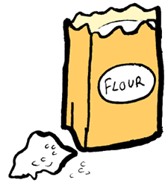

1.5 cups of Flour
La Farrin

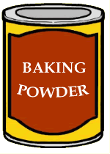
1 tablespoon of baking powder
Pihkasiķan

1/3 cup of oil
Lôwil

¾ cups water
Nipî

1 pinch of salt
Sîwihtâķan

Laķalet – Bannock
1.5 cups of flour
1 tablespoon of baking powder
1/3 cup of oil
¾ cups water
1 pinch of salt

