Pemmican
Teachings shared by Elder Adele Bear
Pemmican is a special food made by Indigenous peoples for thousands of years. It is made by mixing dried meat, like buffalo, moose or deer, with fat and berries. Pemmican was very important because it lasted a long time without spoiling, making it perfect for long trips and winter months. Indigenous peoples, like the Cree and Métis, used pemmican to stay strong while traveling, hunting, or trading. Today, some Indigenous communities still make pemmican to keep their traditions alive.

Cree Words
Pâstêwiyâs – dry meat
Înimina – blueberries
Misâskwatômina – saskatoon berries
Paķamaha – hit
Mâmawina -mix
Mîsco – eat

Materials:
- Dry meat
- Lard – fat
- Berries (blueberries, Saskatoon berries, chokecherries)
- Canvas
- Rocks 1 large one small or Hammers or cutting boards
- Zip lock Bags (snack size)
- Bowls for mixing
- Gloves

How to Make Pemmican

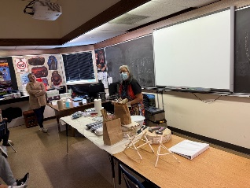 | - Cook the berries in animal fat (lard) in a pan.
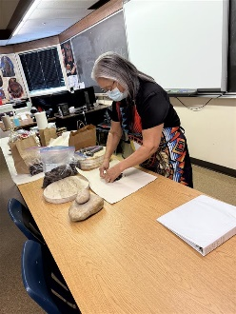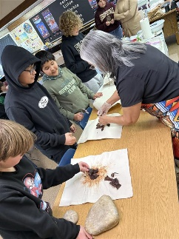 | - Break pieces of dry meat into the middle of a piece of canvas.
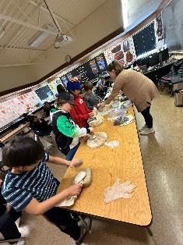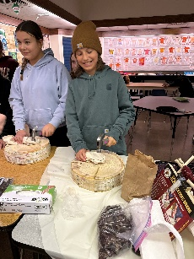  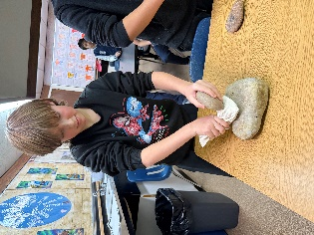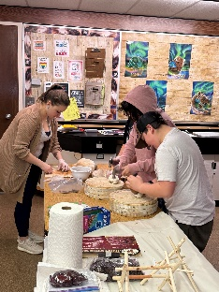 | - Wrap and twist the canvas. Use the rock or hammer to hit the outside of the canvas – to break up the dry meat.  - When the dry meat is into small pieces add it to a bowl.
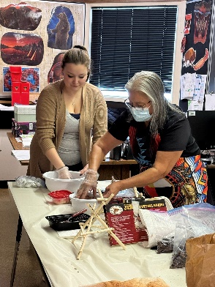 | - Mix in the cooked berries into the bowl of broken-down dry meat. Mix together until texture is sticking together.
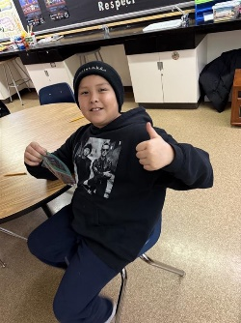 | - Mîsco and enjoy!

