Tuesday, February 25- Bannock on a Stick (Day 5)
Time | Groups of students make Bannock in the kitchen, then take it outside to cook it over the fire! | Take the bowl of dough out to the cooking station outside with Mrs. K and Mrs. A.
10:00
10:30
11:05
11:35
11:55- 12:45 | Lunch and Recess
12:55
1:20
1:50
2:30

Jobs:
- Set up
- campfire pit morning
- bring wood for the fire
- cooking sticks for the Bannock (class set)
- posters with Michif words for ingredients.

- Organize for ingredients
- Flour
- Oil
- Baking powder
- Salt
- Sugar
- Jam
- Butter

- Elder Honorarium Form

Wednesday, January 22nd- Bannock on a Stick

Teachers,
On Wednesday, January 22nd we are very blessed to have Jacinta and her mom, Mary Burnouf, coming in to make Bannock for us. We will be watching and learning how to make Bannock, and then the students will be taking the dough outside to cook it on a fire with Mrs. Andersen and Mrs. Kopperud.
Students can come to Mrs. Pollock’s kitchen in their ski pants, carrying their jackets/touques/mittens, so that they can quickly bundle up and head outside to cook it on our BRAND-NEW FIRE PIT! Once their Bannock is cooked, the classroom teacher can decide whether they want to eat outside or in the classroom.

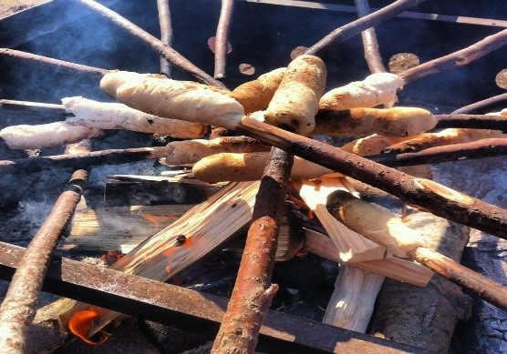
Please see the following schedule. I tried to work around gym and preps, but if I have missed something, feel free to trade with another class and let me know. We will be on a very tight schedule as we include the WHOLE school in this fun activity.
You will also be creating grade alike writing in your PLC time to do after the Bannock learning. Please make sure to complete and help us meet our Lilac goal of bringing more writing to our land-based learning.
Thanks,
Gene

