Indigenous Games – Land-based
Intro
Land Acknowledgement
Walk to gather resources:
- Small rock
- 3 sticks
- 10 sticks that fit into hand

Time  approx. | Game/Activity | Resources | Materials
15 min | Rock in Fist | Rock+in+Fist+FINAL.pdf | 1 rock  3 sticks
15 min | Stick in Fist | Sticks+in+Fist.pdf | 10 sticks with one marked stick
20 min | Métis Sash Tug a War | SYP-flyer.pdf (metisnation.org)  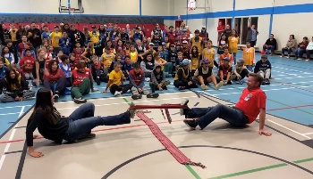 | Sashes
15 min | Stick Wrestle Game:  This game is played in partners. Each person has their front foot against their partners in a forward stance. One hand is on the stick. The stick is to be moved around using different forces and motions, trying to throw their partner off balance. Once their partner’s feet move, then they win. | traditional_aboriginal_games.pdf  page 3 | Sticks
30 min | Double Ball Game | First Nations Double Ball Game Instructions.pdf | 20 sticks  Double balls  nets

9:00 - 10:15 Intro, gather resources, rock in fist and stick in fist
10:15 – 10:30 Break
10:30 – 12:00 Metis sash tug a war, Wrestling games and Double Ball

Afternoon: Grades 7,8,9 teach younger grades

