Métis Trapper Games

A. AGENDA

Events: Time-

Team Leaders:
Take your class from event to event.
Follow the map given.
When the air horn is sounded (every 14 mins), move your class as indicated on the map.

Event Leaders: Your station is your station, so feel free to adapt it as you choose. Students have requested that they be able to try the events in a non-competitive manner and then have the option to compete if they choose to.

Please help the event leader of your last station put away the equipment in the shed(s). This is the responsibility of ALL staff members.

B. EVENTS

Event | Event Leader | Event Description
Nail Driving  Nails, hammers, split logs, safety glasses |  | Cultural Connection:  The most common type of Metis home was the log house. At first they were built by notching the logs so no nails were needed, but with the arrival of Ukrainian homesteaders around 1900, many Métis also began to lath their houses with small willows on an angle, fastened at each end with small nails to help hold the plaster mud in place.  Each competitor will have to drive 2 nails. Nail heads must be completely flush with the surface. Bent nails will not be counted.  (log for demonstration, more nails)
Rope Winding  4 sets of 50’ rope (same length as a fishing line) |  | Cultural Connection: This is skill traditionally learned through working with fishing nets  Relay Race:  Separate students into 4 teams. 1 rope for demonstrator- show them how to wind it. It has to be around the elbow.  1 rope for each team. The first person in each line runs to the end and winds 50 feet of rope around their hand and elbow as instructed. Then unwind, drop the rope and race back, so the next student can go. If they are done early let them leave to get started on putting their snowshoes on.
Snowshoe Racing |  | Cultural Connection: Indigenous people invented snowshoes to travel on foot during the winter. Snowshoes enabled them to walk over knee-deep snow and to hunt without making much noise. During the fur trade, voyageurs, explorers and traders quickly adopted the snowshoe, as well as other Indigenous tools and clothing, to make travelling and working in the winter easier.  Everyone puts on snowshoes to practice. Once everyone has their snowshoes on they line up. When they go they keep track of their own laps. Stop them when there is 4 minutes before the switch for them to take their snowshoes off.  (snowshoes, two pylons)
Log Throwing  3-4 foot long logs |  | Cultural Connection: Metis people often lived in log homes with dirt floors. They were made with rounded logs with notched ends. The roofs were often flat. Mud and hay were put on the outside of the house for added insulation. Log houses in a village were usually built in a circle, with the largest building in the centre. The largest building in the village was generally used for dances and town meetings. Small Metis settlements, or villages, had around 40-50 log cabins.  Each competitor gets two throws. The log has to flip. The longest measurement will be taken.  Demonstrator- show them how to lift with your knees, hands under the bottom of the log. Everyone throws one log for fun. Then see who wants to compete and measure the different throws.  (measuring tape, logs, two pylons for starting line)
Animal Calling  phone with app & bluetooth speaker |  | Cultural Connection: Hunting, trapping and fishing have always been part of the Metis lifestyle. Hunters would make animal calls with their mouths to imitate the sounds of animals.  Each competitor will make the following calls: cow moose, bull moose, alert goose call, spring arrival goose call  Use an app recording of all of the different calls and give students time to practice each one. After they’ve practiced all 4 calls, see who wants to compete and judge the different calls.
Pack Race  3 calf sleds, 45 logs (15 per team) |  | Cultural Connection: During the fur trade, Metis people had to be physically fit. They paddled, portaged, loaded and unloaded canoes and hauled wood and water. Today we are going to do a pack race, which is a winter festival event to test your athleticism and reflect the traditional Metis way of life.  Relay race:  Separate students into 3 teams. The first person in each line will pull their calf sled to the pile of logs and load 15 logs onto their sled before running back. The next person in line pulls the loaded sled to the end and unloads the logs and runs back to pass the sled to the next person.
Trap Setting  Mouse trap |  | Cultural Connection: During the fur trade, many non-Indigenous men married and had children with Indigenous women. The subsequent inter-marriages between Métis women and Métis men, resulted in the formation of a new Indigenous people – the Métis. The definition of Métis as adopted by Métis Nation–Saskatchewan is: “a person who self identifies as Métis, is of historic Métis Nation ancestry, is distinct from other Aboriginal peoples, and is accepted by the Métis Nation.” It is important to note the difference between a non-status First Nations person and a Metis person. Trapping was a central part of the Metis lifestyle.  Students will learn about trapping and learn to make a rabbit snare.
Tea Boiling  4 sets of kindling and cans = 24 kindling (6 per structure) and 4 cans, wild mint |  | Cultural Connection: Metis people traditionally gathered plants and made medicinal teas, over the open fire  Relay race:  Separate students into 4 teams. The first person in each line runs to the end and makes the tea boiling structure and places the pail in the middle before running back to their team, the next person must disassemble the structure and rebuild.
Leg Wrestling |  | Cultural Connection: Leg wrestling is one of the ancient traditions of various First Nations, that were often used as rites of passage for young boys transitioning to manhood. It was also used in physical training and competitions between men of the tribes.  In the gym:  Do a demonstration showing them how to lay down beside each other, link arms etc. Winner is the one who flips the other over.  Use the center line of the gym. Find a partner. If you lose you move towards the sound room office. If you win you stay on the center line.  New battle every minute or so. Eventually you will have a final battle that the rest can watch.  After a winner is determined, send the students back out the bus door to get their shoes and go around the front of the school to the Aunty Says station
Aunty Says |  | Cultural Connection: Indigenous people in our area speak Y Dialect Plains Cree, Northern Michif & Dene.  Aunty Says (Simon says) – Classes will learn some basic northern michif & Y dialect Cree commands (walk, run, jump, come here, go away, eat, sleep etc.) and play Aunty says.
Portage Race  Fill potatoe sacks with balls. Or  Items that students have to carry from one side to another. |  | Cultural Connection:  During the fur trade, Metis people had to be physically fit. They paddled, portaged, loaded and unloaded canoes and hauled wood and water. Today we are going to do a pack race, which is a winter festival event to test your athleticism and reflect the traditional Metis way of life.  Students will race to carry items from one side to another.
Sash Tug a War  5 sashes |  | Cultural Connection:  The Metis sash is a big part of the Metis identity. Traditionally, the sash had a numerous amount of uses such as: a washcloth, to carry items, keep track of days, assist with hunting and carrying items.  Tie the sash together. Students sit down on butts across from each other. Wrap the sash around one foot each together. Students pull on sash to try pull the other person over.

Métis Trapper Games

8. Animal Calling

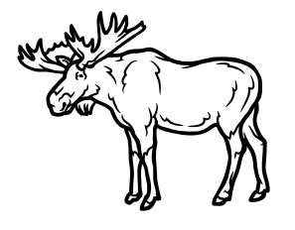
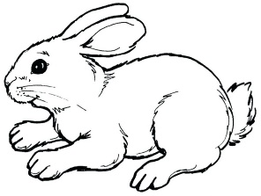

7. Trap Setting




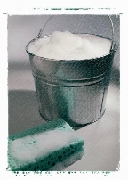

9. Leg Wrestling in Gym
6. Pack Race

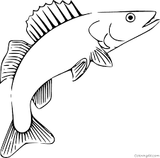
3. Snowshoe Racing
5. Tea Boiling

10. Aunty Says

- Nail Driving
2. Rope Winding
4. Log Throwing

