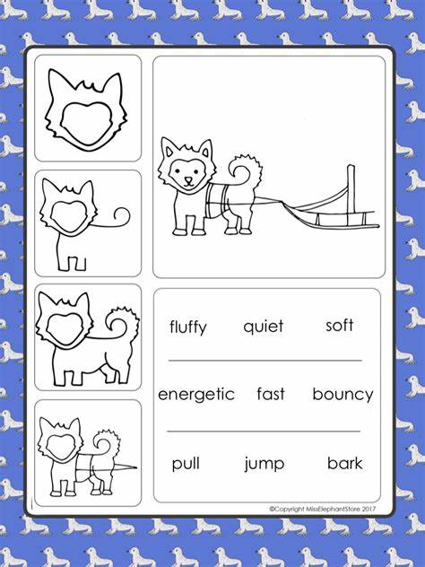
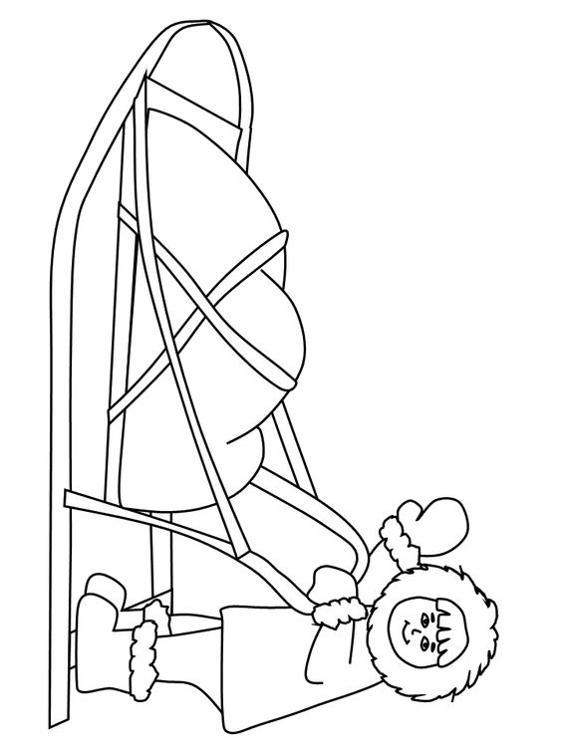
Dog Sleds
We will have the Connor Family at our school on Friday, March 3rd. Here are some activities you can use to activate prior knowledge, strengthen understanding, and generate questions/discussion prior to the event. These are just a guideline. Feel free to be creative and incorporate high-impact learning strategies where you can!
Dog Sledding Read Alouds-
There are a variety of read alouds displayed in the office.
Get Epic
There are a lot of great resources (fiction & non-fiction) on Get Epic if you search “sled dogs”!
www.getepic.com
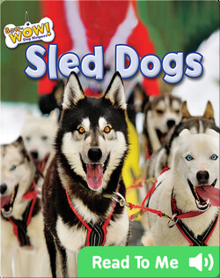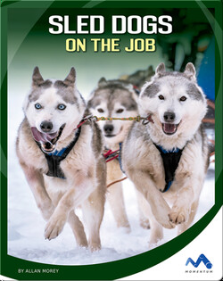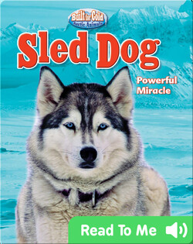
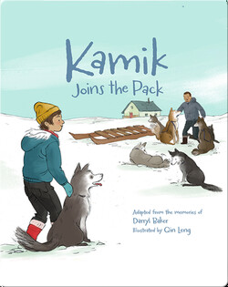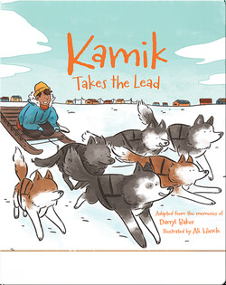

YouTube- Links are on Teams
Sled Dogs | Pre K books read aloud | - YouTube (4:02)
Non-Fiction Read Aloud for early grades- can talk about non-fiction text features, and retell the main idea/details.
Sled Dogs in Summer | Molly of Denali - YouTube
Kids in Anchorage, Alaska visit a kennel to show us how sled dogs train in the summer when there isn’t any snow on the ground.
Lot’s of other read alouds if you do a search!

Dog Sled Writing Prompts
What did you learn about dog sledding?
I would be a good musher because…/ I would not be a good musher because…
If I was a musher….

Additional Resources
A variety of other reading comprehension/writing/ELA activities can be found at the display! Look through and choose activities based on your student’s unique abilities!

After the Dog Sleds…
After students have participated in the dog-sledding experience on March 3rd, they will fill out an exit slip, so we can collect some student voices!
Please see attached and choose one best suited to your grade/individual students, or create your own!

Dog Sledding

Draw a picture of the dog sleds.

What did you enjoy about dog sledding?
____________________________________________________________________________________________________________________________________________________
I felt_____________ because__________
__________________________________________________________________
Dog Sledding

Draw a picture of the dog sleds.

I felt ____________________________
because____________________________________________________________
Dog Sledding

What did you enjoy about dog sledding?
_________________________________________________________________________________________________________________________________________________________________________________________
What did you learn about dog sledding?
_________________________________________________________________________________________________________________________________________________________________________________________
I felt_____________ because__________
__________________________________________________________________

Dog Sledding

What did you enjoy about your dog sledding experience?
__________________________________________________________________________________________________________________________________________________________________________________________________________________________________________________________________________________________________________________________________________________________________________________________________________________________________________________________________________________________________________________________________________________

What did you learn about dog sledding?
__________________________________________________________________________________________________________________________________________________________________________________________________________________________________________________________________________________________________________________________________________________________________________________________________________________________________________________________________________________________________________________________________________________

Why is it important to learn about the history of sled-dogs?
______________________________________________________________________________________________________________________________________________________________________________________________________________________________________________________________________________________________________________________________

How did you feel about this land-based learning experience and why?
________________________________________________________________________________________________________________________________________________________________________________________________________________________________________________________________________________________________________________________________________________________________________________________________________________________________________

How do you feel when cultural events are held at our school? What did you learn about dog sledding?
___________________________________________________________________________________________________________________________________________________________________________________________________________________________________________________________________________________________________________________________________________________________________________________

