2018 Grade 5 Supply List
24 HB Pencils – if you send mechanical pencils please make sure you send lead as well
4 Erasers
Pens (2 black or blue, 1 red)
1 Whiteout
1 Highlighter
2 Pencil Cases
1 Pair of Scissors (Fiskars)
1 White Glue
2 Large Glue Sticks
5 Duotangs (different colors if possible)
2 -2 inch binder (plain-jane please: no zipper binders)
2 –1 inch binder (plain-jane please- no zipper binder)
1 package of dividers
4 Hilroy Notebooks-32 pages (no coils please!)
2 Pocket Folders
1 Package of Pencil Crayons (sharpened) (a package of 24 is plenty)
1 Package of Wax Crayons and/or Markers (both optional!)
1 Ruler (30 centimeters)
4 Boxes of Kleenex
1 Water Bottle
1 Pair of Gym Shoes (No Board Shoes and Non-Marking Soles)
Gym Clothes
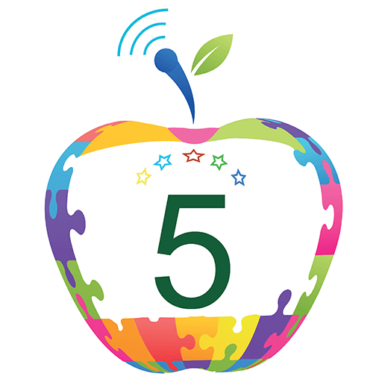
1 Pair of Headphones (in a labelled Ziploc bag)
1 Large Labelled Ziploc Bag- for extra supplies
$10 for Agenda

Excited to see you in the Fall! Have a great summer!!
Miss Mannix

