GAS Early Years Plan
The following Early Years Plan template is offered to assist school divisions and First Nations authorities to implement high quality actions to support children to be ready to learn in the primary grades. Please refer to Responsive Teaching, Practice and Assessment in Early Learning Programs when developing your plan.
The Early Years Plan template is divided into three timeframes: Analyze and Interpret (after Fall EYE data is available), Create a Plan (after analysis of EYE Fall data has occurred) and Evaluate Effectiveness, Respond and Adjust (after Spring EYE data is available).
School Division: GAS (Northwest School Division # 203)
Contact(s): Michelle Hildebrand, Michael Radford Phone Number: 306-236-5905
Elements | Analysis of Current Situation at GAS | Actions for Schools/Classrooms
Analyze and Interpret
Timing: After Fall Early Years Evaluation (EYE) data is available
Research, Data and Analysis | GAS EYE-TA Data:  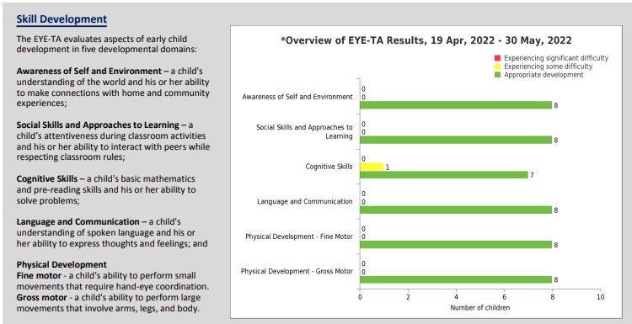  GAS data shows that we have a student who is Tier 2 in Cognitive Skills – a child's basic mathematics and pre-reading skills and his or her ability to solve problems  GAS Kindergarten screens- SLP and OT (including hearing screens) | Share information with parents and community through EYE reporting period and conversations during report cards (SPTI)  GAS will create an Early Years GAS data team (K, Grade 1, SSST, admin, etc.)  GAS will meet after EYE results are available and report on data  Consult with SLP and OT when examining and responding to Eye Data  GAS will Collaborate with RtI team to discuss data and develop a school plan to respond  Gas children with Tier 2 learning needs will receive targeted, small group instruction that can be provided within or outside the classroom  GAS Kindergarten teacher and EA will use the Eye 100 Activities to strengthen cognitive skills (one literacy and one numeracy)
Responding to Data |  | Continued PD and training for promising practices for responding to data and the needs of GAS Kindergarten students (Predominantly use EYE Resources and Help Section)  GAS will continue to consult and collaborate with SLP/OT when responding to data and creating a plan moving forward  Specific Actions:  - Respond to Results (with above in mind)  - Use Eye 100-Domain Strengthening Learning Activities to address student needs  - Use collected EYE-TA data to inform LIP planning  - Use collected EYE-TA data to support Early Literacy Development
Create a Plan
Timing: After EYE Fall data is available and analysis has occurred
 |  | GAS will continue to provide Eye See Eye Learn information to K and grade one families
 |  | GAS K teacher and EA meet regularly to discuss EY programing and EYE results
 |  | GAS will continue to consult and collaborate with SLP/OT when responding to data and creating a plan moving forward
 |  | GAS will support families, build relationships, track attendance, and follow up to ensure kids get to school (WCs)
GAS EY/Rti teams meet regularly (Thursday) to develop, implement, and refine EY plan based on:
- triangulated data collected from the classroom (As/For/Of Learning)
-collected Eye Data,
and consultation with SLP/OT/SSST/Admin
 |  | Administer learning and cognitive assessments in K if needed (SLP/OT/Ed Psych)
Evaluate Effectiveness, Respond and Adjust
Timing: After EYE Spring data is available
Research, Data and Analysis |  | GAS EY/Rti team meet to analyze data and adjust resources/staffing accordingly  GAS school team will submit an Early Years plan and a follow up meeting will be scheduled
Transitions |  | GAS teachers will schedule transition meetings for all tier 2/3 students (K)  GAS will have planned interventions in place right away in Sept  GAS will assign SSST time to support tier 2/3 students leaving Kindergarten  GAS will continue Individual transition plans for students on IIPs  GAS will Plan K transitions to gr. 1 starting in May
Respond and Adjust |  | Promote and advertise K in our communities  GAS K areas of focus- cognitive and language and communication. GAS will utilize EYE 100 activities to strengthen domains  GAS will continue to collaborate with SLPs, OTs, psychologists, and counsellors to identify barriers and gaps and to design PD to respond to needs  GAS will continue to look at our Rti programs in K and tweak them to meet the needs of our students  Use NWSD developed “Look Fors” in GAS K classrooms (help guide planning, assessment, intervention)  GAS will use Literacy Pathways continuum for Early Years that NWSD has developed

Superintendent/Early Learning Consultant Signature__________________________________________ Date_______________________

