Date: October 6, 2017
Marshall School’s
Annual
Turkey Dinner
Time: 11:30 am – 1:00 pm
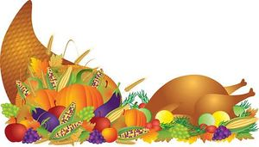
Place: Marshall Three Links Hall
Adults & Students - $12
Children (6 + Under) - $5
**Marshall School students eat free of charge

