Name: | Neilburg School Community Council
Mailing Address | Box 309 Neilburg, SK S0M 2C0

Meeting Date: | March 9/22
Meeting Called to Order: | 4:02
Date of Next Meeting: | TBA
Meeting Adjourned: | 5:12pm

Attendees:
Y | N | Brooke Forbes | Y | N | Sarah Hein
Y | N | Sara Goodfellow | Y | N | Stacey Mills
Y | N | Bev Nattress | Y | N | Rachel Wightman
Y | N | Ria Wiens | Y | N | Ashley Weinkauf
Y | N | Principal- Wade Warman | Y | N | Teacher Representative- Candice Steveson
Y | N | Student Representative- Justine Nattress

Meeting Agenda Items
Y | N | Secretary Report: Sarah presented
Y | N | Financial Report: Bev presented
Y | N | Principal Report: No Principal report this month
Y | N | Old Business
Y | N | New Business
Y | N | Other:

Topic | Discussion | Action Taken or Proposed | Person Responsible | Target  Date
Reports
Secretary Report | Sarah presented the Secretary report and adopted to move minutes as read. | All in Favour
Treasurer Report | Bev presented Treasurer report.  School Acct $4807.71  Division Acct $6872  Bev adopted to move report as read. | All in Favour
Principal Report | No Report this month
Old Business
Highschool Girls Bathroom | Bathroom doors are painted and hung. We will come up with some vinyl options and let the each Grade (7-12’s) vote on one door. Put the Radiate Positivity on the Large door.  Also lower the mirrors above the sinks so they are at an appropriate height. | Everyone come up with 4/5 ideas and put on our group chat by Friday for options to have the girls vote on.  Ashley to get a quote from Reid signsas they can do the vinyl all in one, rather that strips of each colour.  The mirrors above the sinks need to be lowered and that might need to go through the Division to get done. Sara to mention to Wade to put that request in. Sara talked with Wade and the mirrors will need to be broken and soap dispensers removed in order to get them off. The Division to take over this, | All/Sara  Ashley  Sara/Wade | Mar 11/22  Mar 31/22  Complete
Home Ec Supplies | In the past we made a motion to help buy supplies for the Home Ec room. They are running the classes again and have made a list of items that are needing upgraded. Sara has the list | We will do up a letter to see if stores like Canadian Tire will donated towards it, and then revisit what is remaining, and the costs after. Ashley to resend the letter through email so we have a paper trail. | Ashley | March 31/22
Exterior Painting of the school | A letter was drafted and sent to the Division asking for an exterior upgrade. | Ashley received a reply. We need to address certain areas if we would like it pursued further. | All | April 2022
Library Games | We are still in search for Library games, there have been a few donated. | If anyone is going to The Olive Tree or Restore have a check for what they have for used games. If you see any of the games that are on the list pick up and let the group know that it is handled. Labyrinth, Catan, Scrabble, Dominoes, Gavity Maze. | All | Complete
Treasurer Position | Charmaine has stepped down from the Board and as a result the Treasurer position needs to be filled | Bev has agreed to take on the treasurer roll for the remainder of the year | Bev | Complete
President Position | Ashley would like to step down from the President position, but remain on the board to become familiar with the roles. | Sara agreed to take on the President position for the remainder for the year | Sara | Complete
Hot Lunch | Subway Feb 17th | Forms have been sent out.  Pick up in Lashburn  Sara will look into schedules to see what other groups have planned for the remainder of Feb/Mar and we will decide from there if we do more | Ashley  Sara | Complete
New BBQ | Sarah suggested we look into getting a new BBQ for the school  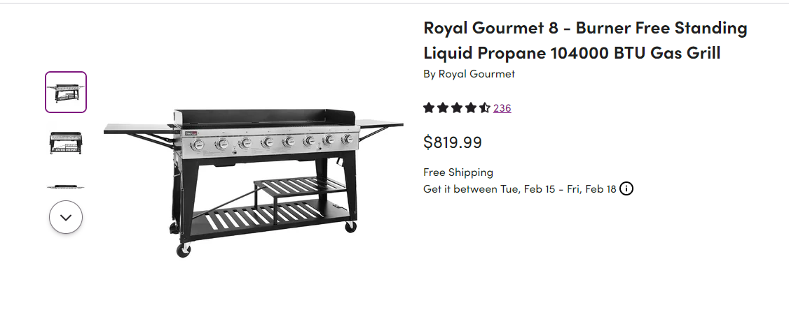 | There is an 8 burner on Wayfair for $820.  Everyone do a little research on types/styles for the next meeting.  Touch base with Costco regarding As Is/Display items  Watch for sales. Put it on the chat if you come across something. | Sarah  All | April 2022  April 2022
New Stoves for Home Ec Room | Candice suggested we look into new stoves for the Home Ec room | There are probably 2 that should be replaced. Ashley will ask Wade if this is something the Division will purchase, since it is for the Home Ec class. Wade figured stoves are fine for now.  Wait for Ms Ross to use for 4th quad and get a report/update from her.We will table until the fall. | Candice/Sara | Fall 2022
New Business
Spring Event | Plan a spring event since we had to cancel our Winter Fest.  Decided to have a BBQ June 16th from 4-6:00.  We have a co-op gift card with returns on it we can use to purchase items | We could set up soccer/ dodge ball/other games.  Will run similar to our fall bbq, come and go an kids can start packing up supplies and take home so they don’t have as much on the last day. | All | June 16/22
Letters above the Kindergarten Lockers | Mrs Perkins asked for help to hang letters above the Kindergarten lockers. | Justine volunteered to take care of this | Justine | Complete
Mrs Perkins-SBIF help | Mrs Perkins is putting together math games for teachers to use in their classrooms. | She could use help cutting/laminating items and was wondering if we could help her out. Put on group chat when/if someone is available. | All | April 2022
Hot Lunches | March 10- Subway  March 25- Pizza  March 31- Subway  April 12- Subway | Ashley to pick up  Ashley cooks 2  Rachel cooks 4 at the Church  Sarah cooks remainder at the hall  SRC to help serve  Bev to pick up  TBD | Ashley  Ashley/  Rachel/Sarah  Bev | Mar 10/22  Mar 25/22  Mar 31/22

