Cooking and eating together are great ways to connect as a family and to learn life skills.
Cooking together can:
Cook and Eat - Together

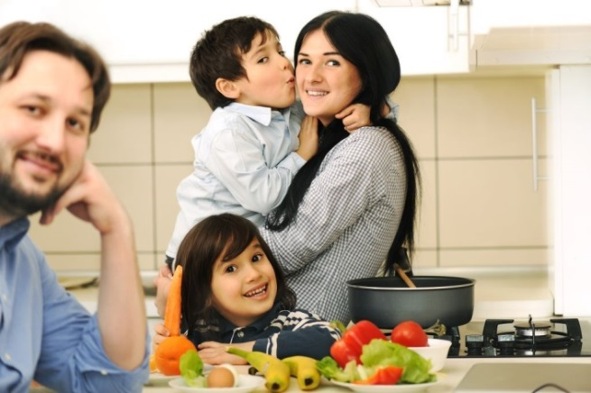
- help children learn math, spelling, reading, science and health
- help kids learn to enjoy a variety of foods
- help adults model healthy eating habits for children
- happen at home, at school or during after school activities
- be a chance to learn together. Check for cooking classes at your local community centre, community college or a local grocery store.
Eating together can:

- help families and friends to learn and listen to each other
- help preschoolers to learn more words
- help teens do better in school and avoid risky activities such as smoking, using drugs or alcohol
- help adults and children to have better eating habits
- be possible but needs to be a priority.
Making it happen

- Plan meals ahead: It is important to make a plan. If you leave it to chance, family meals will be hard to make happen regularly.
- Fit family meals in: Look at the activities for the week and as a family make a plan of action for how you will organize meals around the schedule. Once you have figured out what works best for your family’s schedule, you can make an actual plan.
- Start small: Don’t plan too many meals at once – small changes are easier. Start with 3 or 4 meals and give the family a few nights for leftovers or a meal out.
- Keep it easy. Change can be hard to maintain particularly when life gets busy. There is no need for fancy meals. Grilled cheese sandwiches and salad is a great dinner on a rushed night.

For more information about family meals or for quick recipes go to www.dietitians.ca or www.canada.ca
Written by the Public Health Nutritionists of Saskatchewan (2018)
Distributed by Stacey Wiens, Public Health Nutritionist, North Battleford, Meadow Lake, Lloydminster and Area
Saskatchewan Health Authority

