Save The Date!

Dear families,

Mark your calendars! The fun and excitement of a Scholastic Book Fair is coming to our school!

So save the date! Our Scholastic Book Fair will take place on Oct. 18th-21st

And for parents, friends and family that can't join us in the school, be sure to join us online with our Virtual Book Fair Extension! Our online shop will be open on the first day of our Fair, but you can view a selection of the books you'll find here:

https://virtualbookfairs.scholastic.ca/pages/5167359

Watch for news leading up to our Scholastic Book Fair!

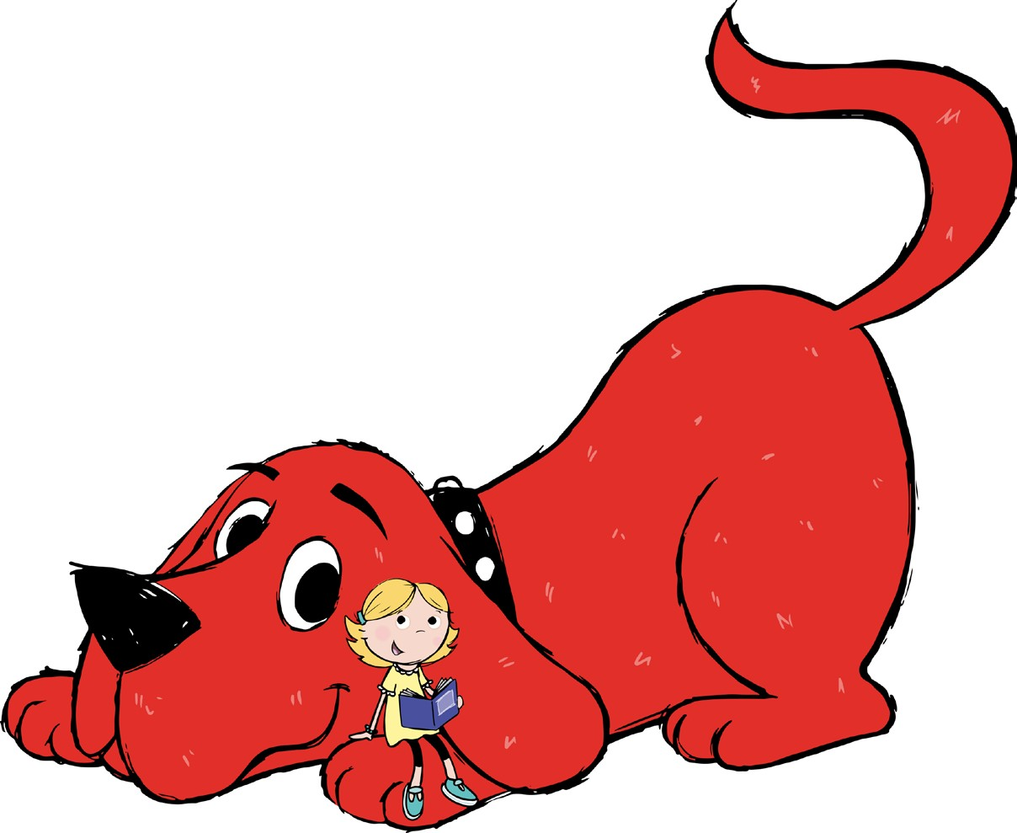
Happy Reading!

